**Chapter 10 G/L**

*In This Chapter:*

**10.1 New Journal (Office Account)**

**10.2 Manage Journal (Office Account)**

**10.3 New Journal (Clients’ Account)**

**10.4 Manage Journal (Clients’ Account)**

**10.5 Manage Bank Recon**

**10.6 New Unpresented Cheque (Office A/C)**

**10.7 New Unpresented Cheque (Clients’ A/C)**

**10.8 Manage Unpresented Cheque**

**10.1 New Journal (Office Account)**

This section is to create a new journal entry for office account.

* To open New Journal (Office Account), on the **SmartLeg@l** navigation, click **G/L** and go to **New Journal (Office Account)**.

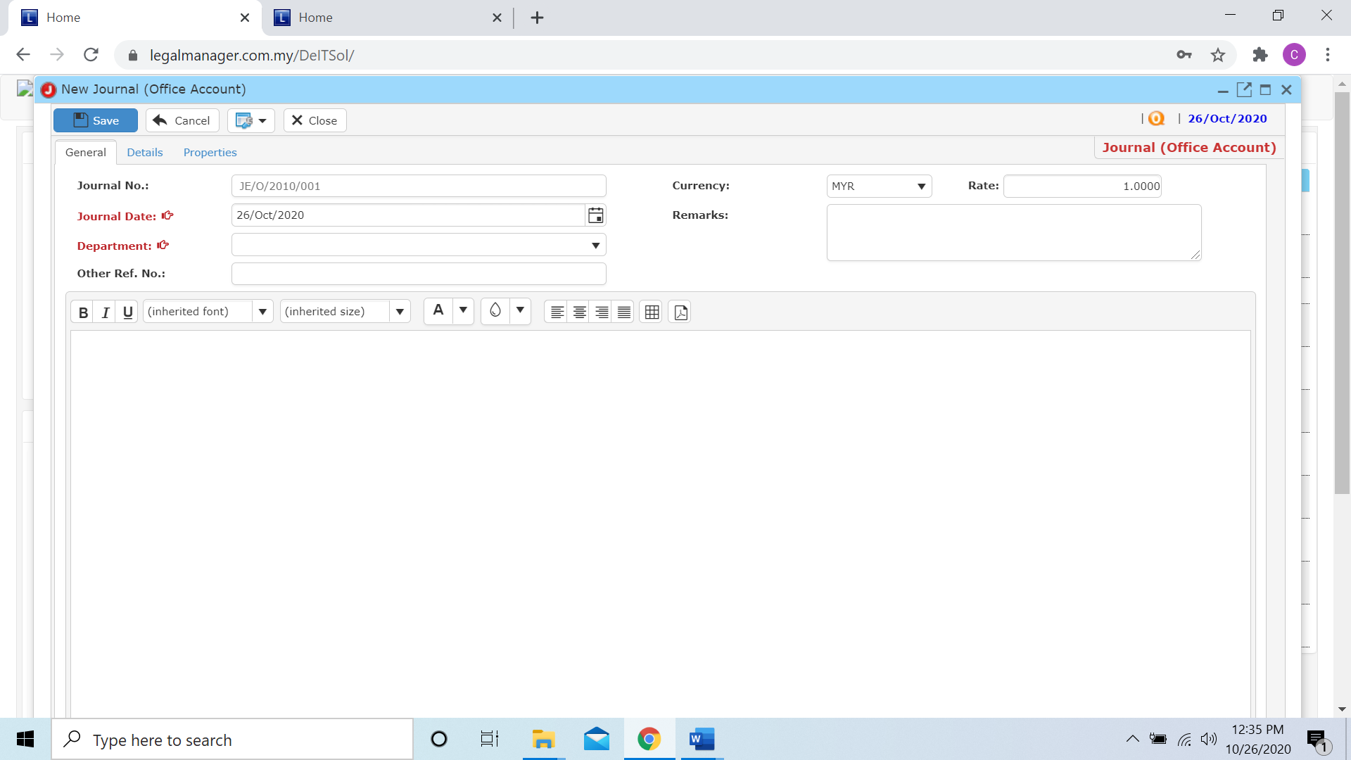

* Key in or select the journal date from calendar, by default is the date you click to new journal
* Choose a department from combo box and fill in other related information
* After that, you can click to the next tab ‘Details’

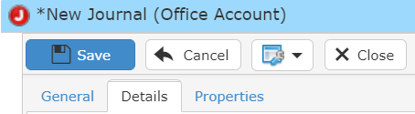

* When you click to the details tab, you have to insert the activity and select the amount either credit or debit

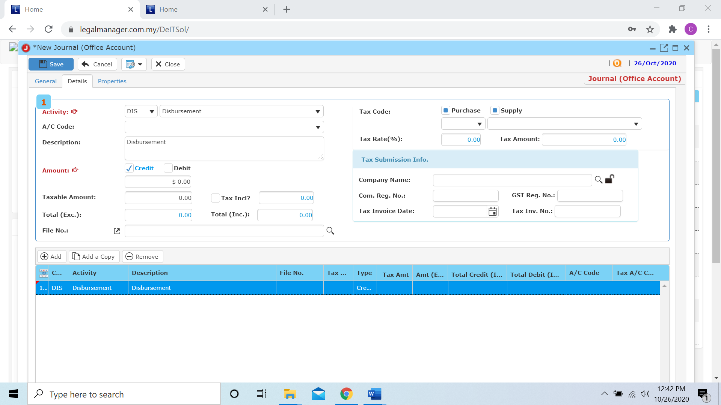

* Other than that, you can Add, Add a Copy or Remove in this section



**Add**

* When you click ‘Add’ it will come out a new row and follow the process of above select and key in the activity.

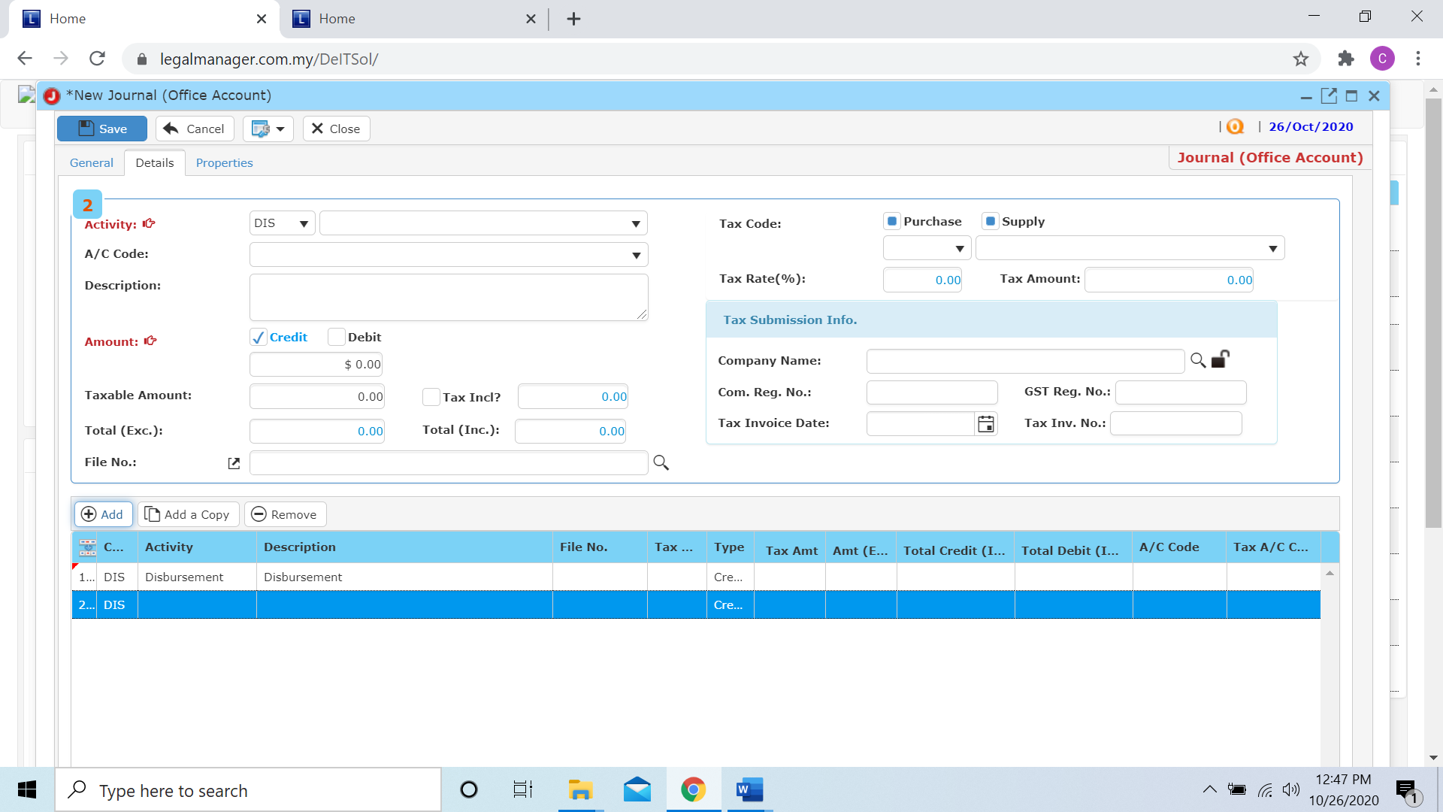

**Add a Copy**

* For Add a Copy, you can duplicate a selected row in the table

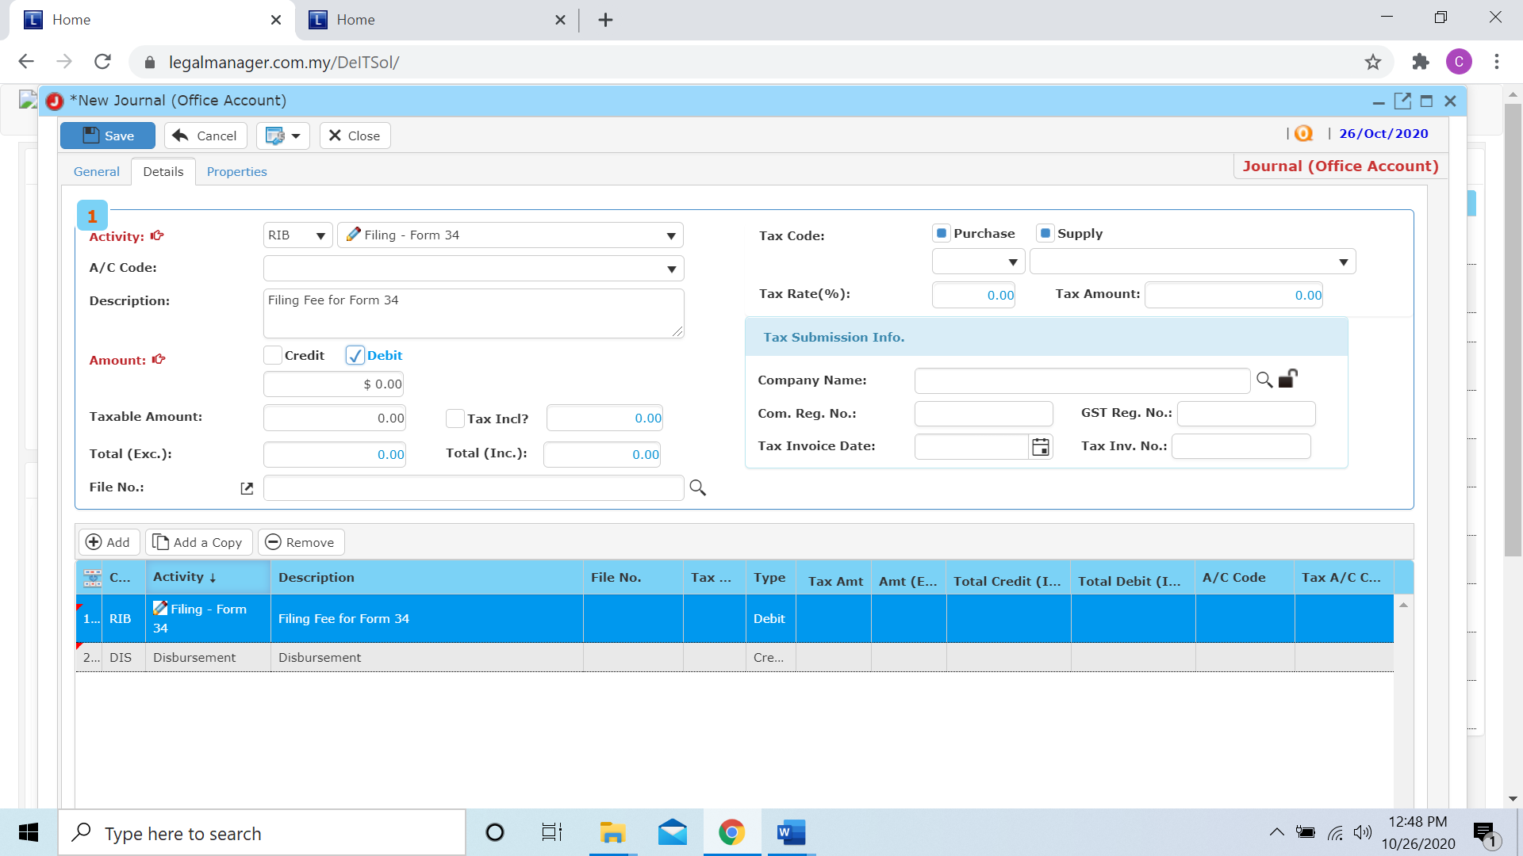

* After you click add a copy, it will copy the row as below figure shown

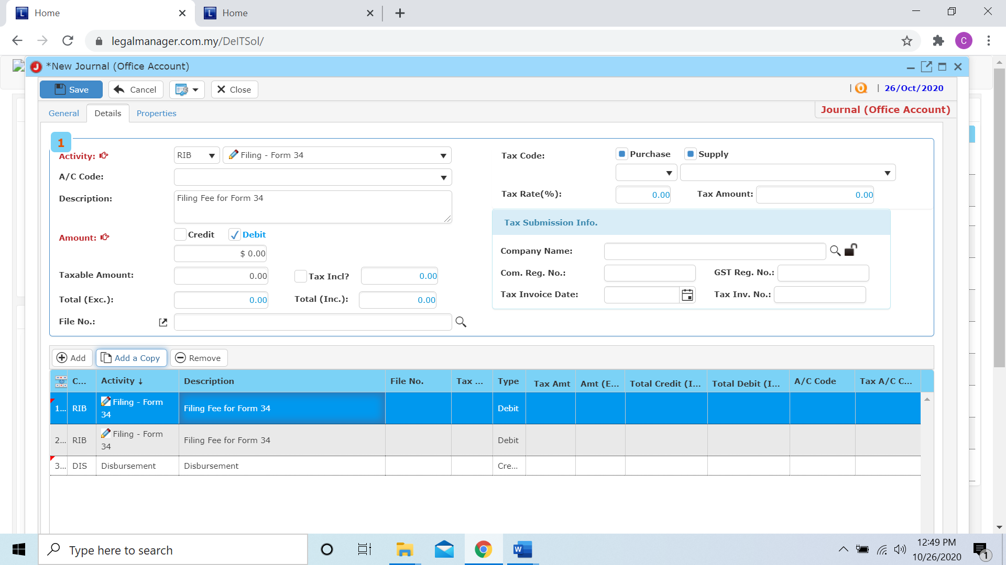

**Remove**

* For the remove, you have to select the bill in the list and click remove to erase the bill

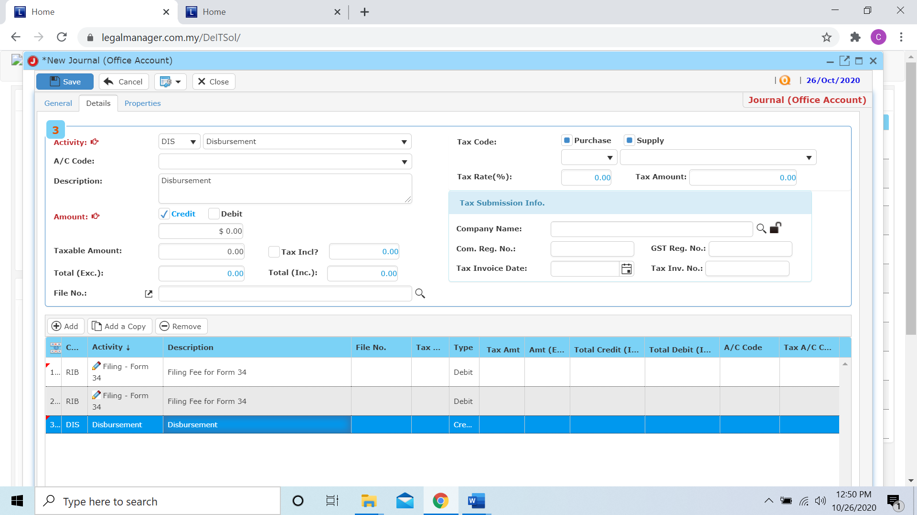

* After you click the remove button it will erase the selected row

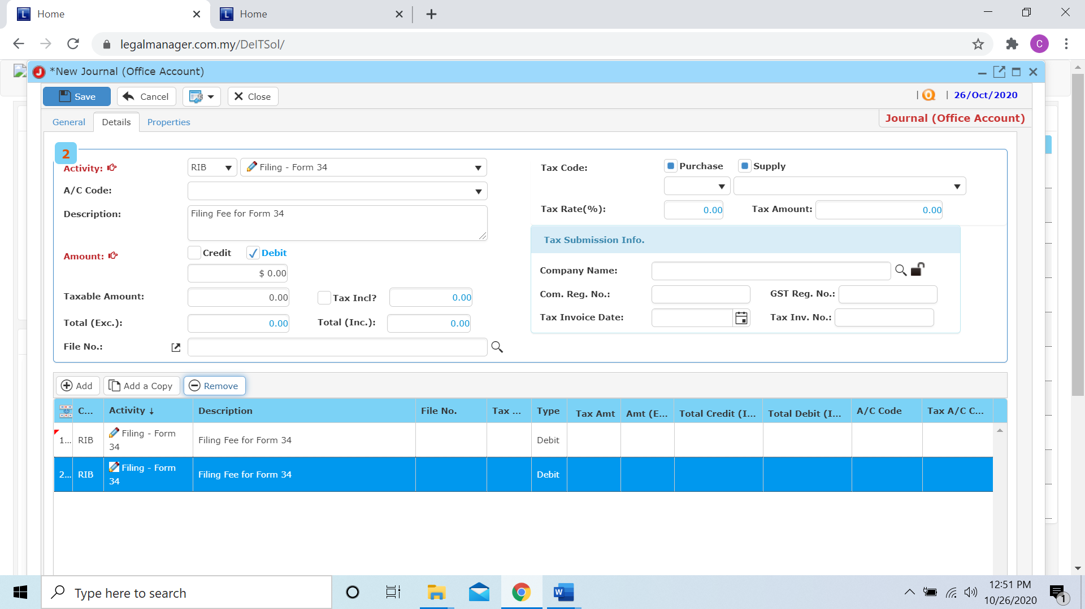

* When you finished in the details tab, you can click to the next tab ‘Properties’

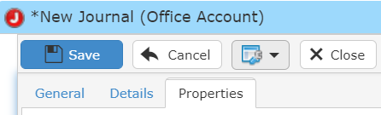

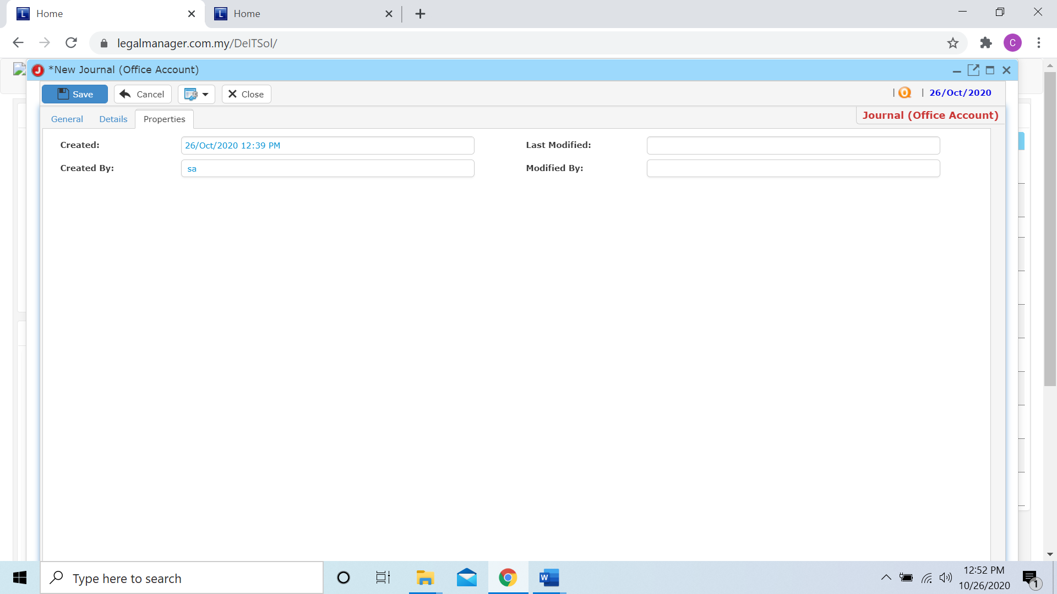

* You can view the information of the journal once who modify the journal then there will show the last modified and modified by who
* Once you finish all the instruction above, click ‘Save’ then you are done to create a new journal (office account).

**10.2 Manage Journal (Office Account)**

This option enables you to add, edit, and delete an office account journal. It also allows you to keep track of your journal (office account) details and all related information.

* To open Manage Journal (Office Account), on the **SmartLeg@l** navigation, click **G/L** and go to **Manage Journal (Office Account)** then search the journal you wish to modify.

**Manage Journal (Office Account)**

* Search the journal you wish to manage through type the search criteria or search by advanced.
* To start a new search or to clear the search results, click ‘**Clear**’.

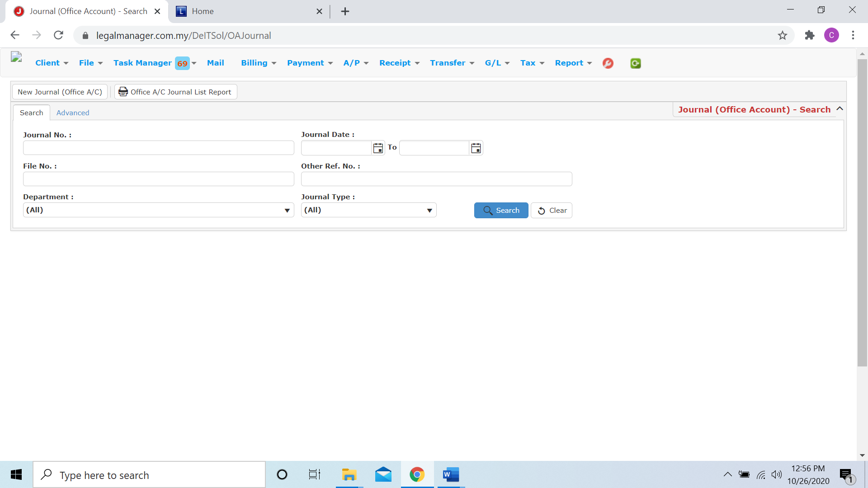

Figure: Manage Journal (Office Account) - Search

**Advanced Search**

* This function can be used to find a journal by searching other information that is not captured in the ‘General’ section.
* Define search criteria:

**- Field** - Choose the field you want to search.

**- Condition** - Search condition

**- Value** - Type in the detail you want to find.

* Click ‘**Add to list**’, to define more than one criteria.
* Click ‘**Find**’, search results will be displayed at search record list. You can open an item in the search results list by double-clicking.
* To start a new search or to clear the search results, click ‘**Clear**’.
* Click ‘**Export**’ to print the desired search results in txt, excel or html format.

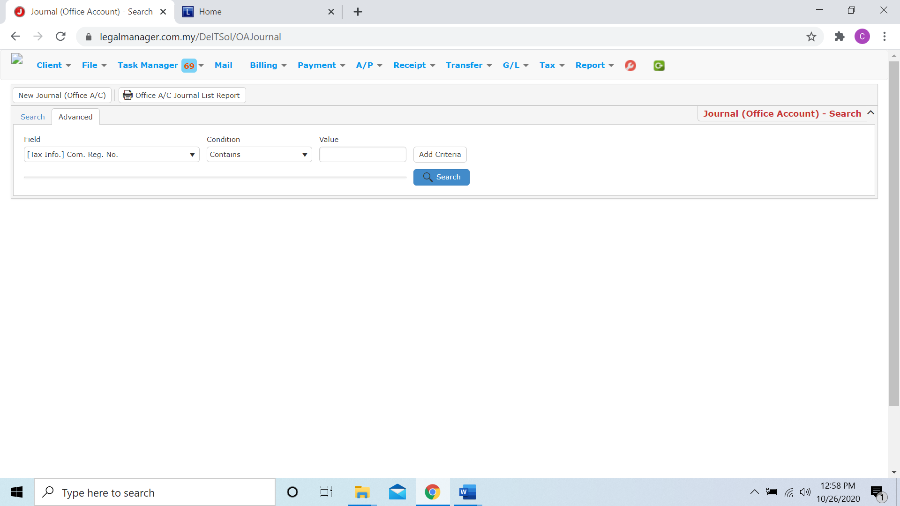

Figure: Manage Journal (Office Account)– Advanced Search

* You can choose to create a new journal (officea/c) by click  and refer to ‘Chapter 10.1 New Journal (Office Account)’
* You can print or preview the Office A/C Journal List Report while you click to 
* Then it will pop-up a Office A/C Journal List Report you can insert your requirement and filter the report

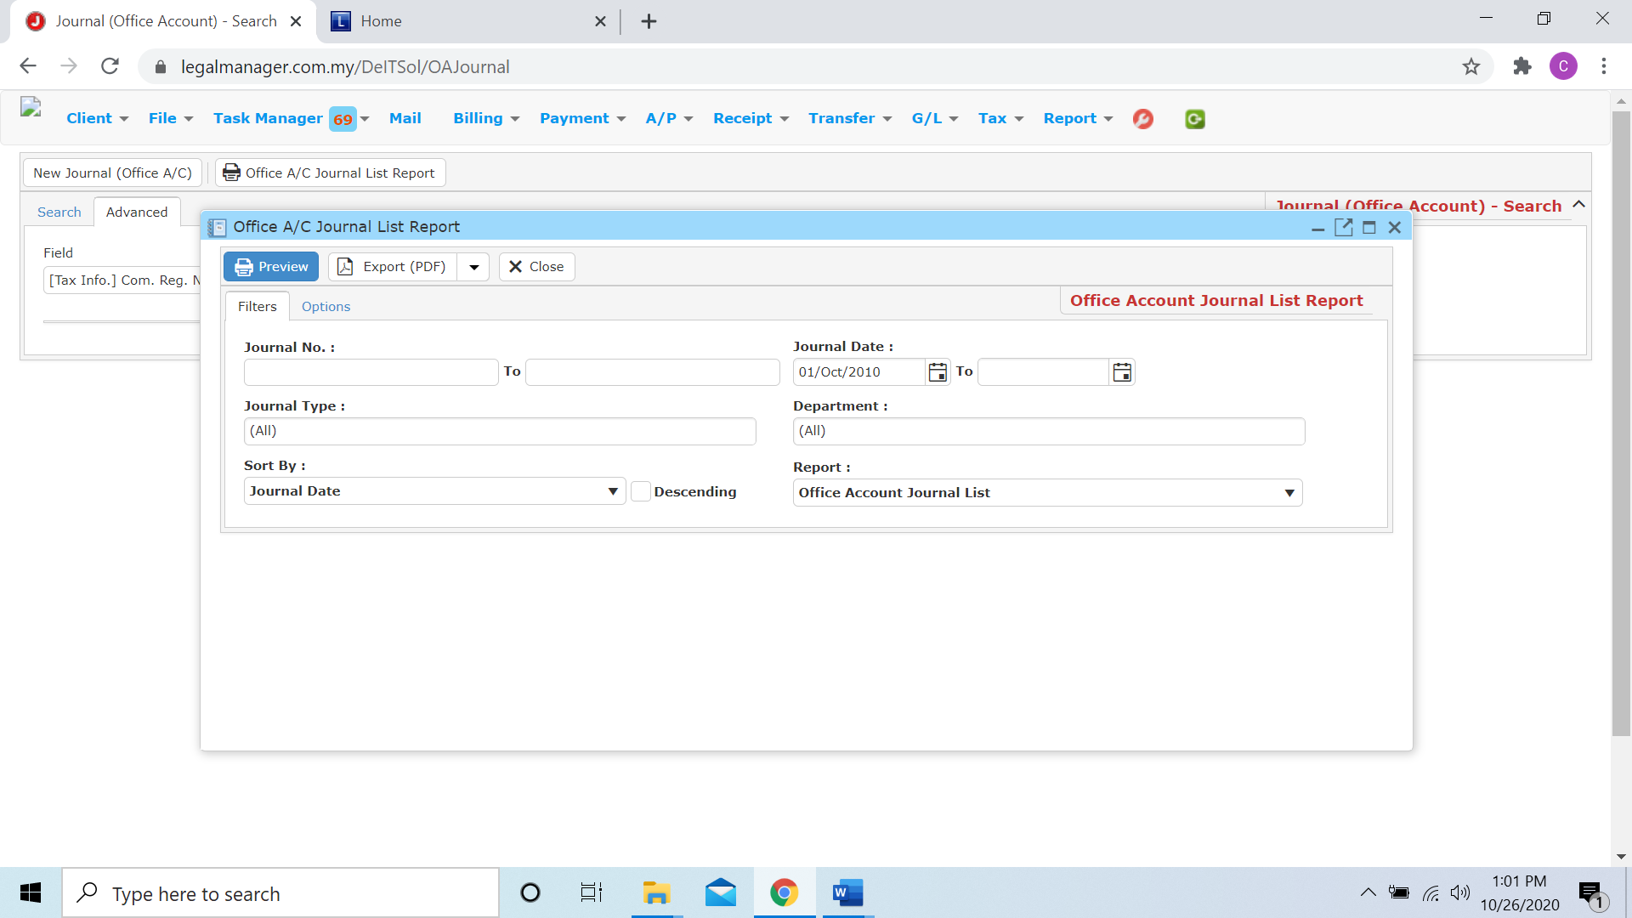

* Besides, you can preview the report as figure below shown

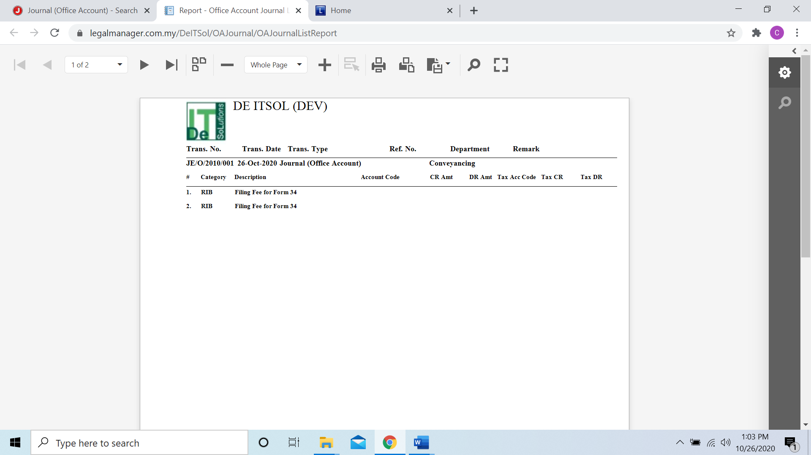

* You can also export the report into PDF or excel by clicking

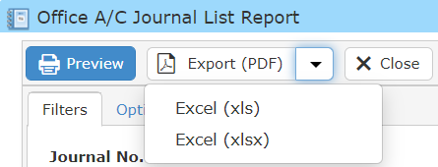

**Searched Result**

* Click ‘**Search**’ once, to show all journal of office account
* The Searched result will appeal at below, otherwise it will shown no record availble if the quotation you searched do not exist.
* Click ‘**Export**’ to print the desired search results in txt, excel or html format.

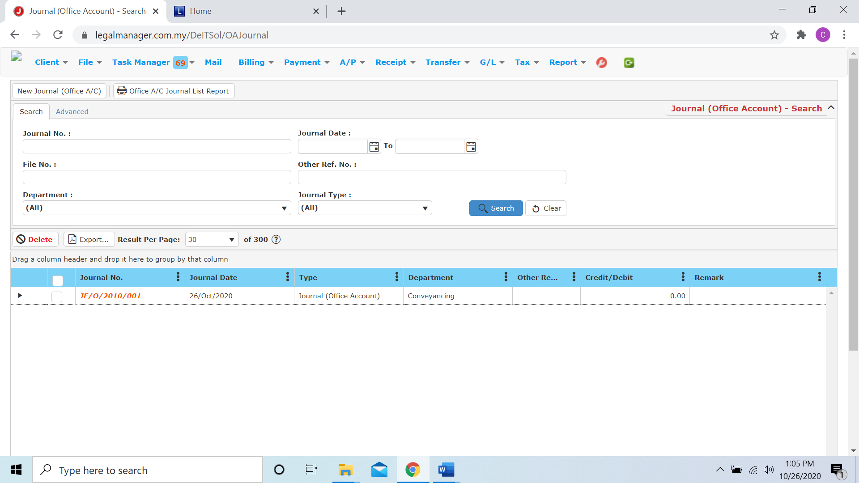

**10.3 New Journal (Clients’ Account)**

This section is to create a new journal entry for clients’ account.

* To open New Journal (clients’ Account), on the **SmartLeg@l** navigation, click **G/L** and go to **New Journal (clients’ Account)**.

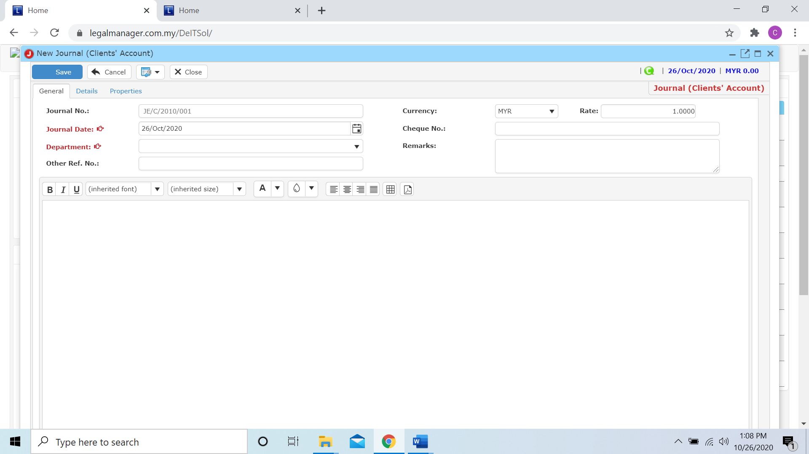

* Key in or select the journal date from calendar, by default is the date you click to new journal
* Choose a department from combo box and fill in other related information
* After that, you can click to the next tab ‘Details’

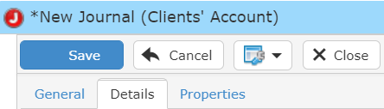

* When you click to the details tab, you have to select both activity and A/C code

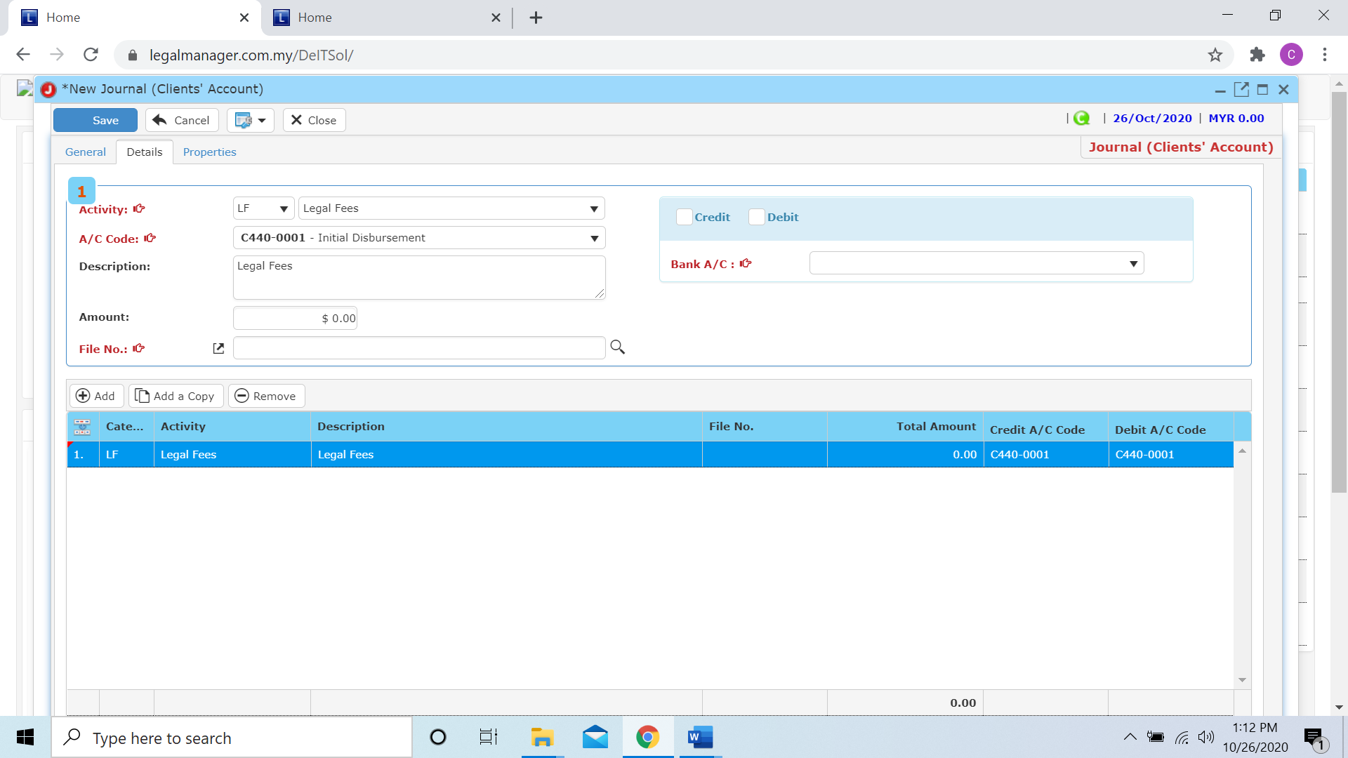

* Besides, when you wan to fill in the File.No you can click the search icon  to browse files with search file master other than type it out, click ‘search’ once to search all files

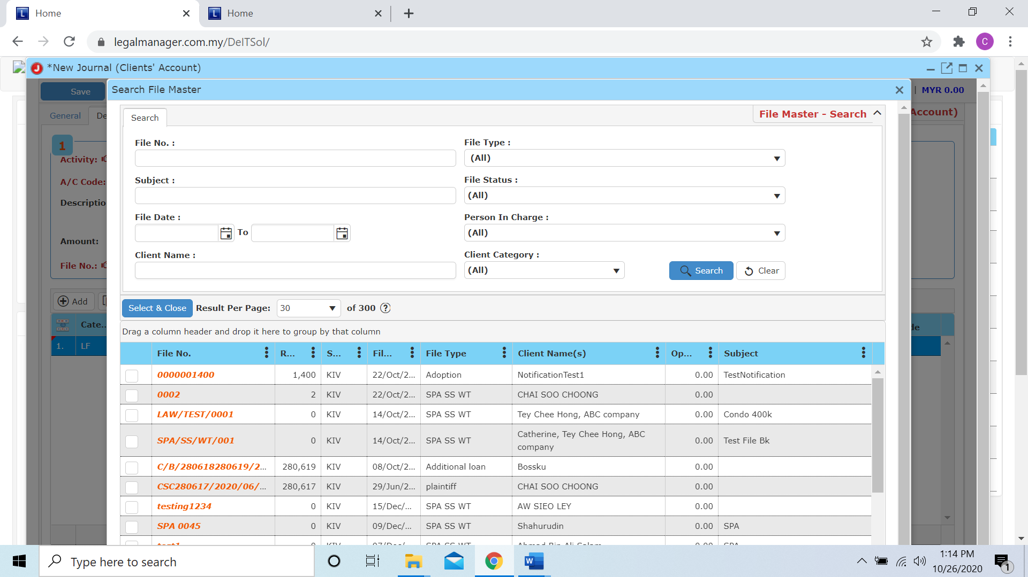

* Moreover, you have to insert the Bank A/C and decide the journal should be credit or debit

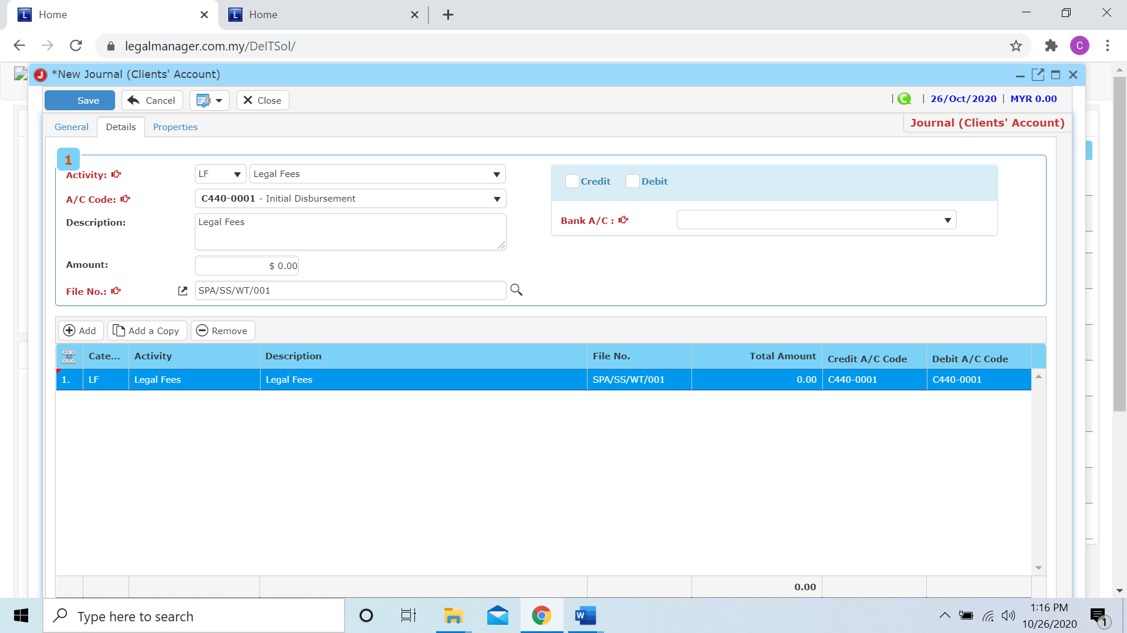

* Other than that, you can Add, Add a Copy or Remove in this section

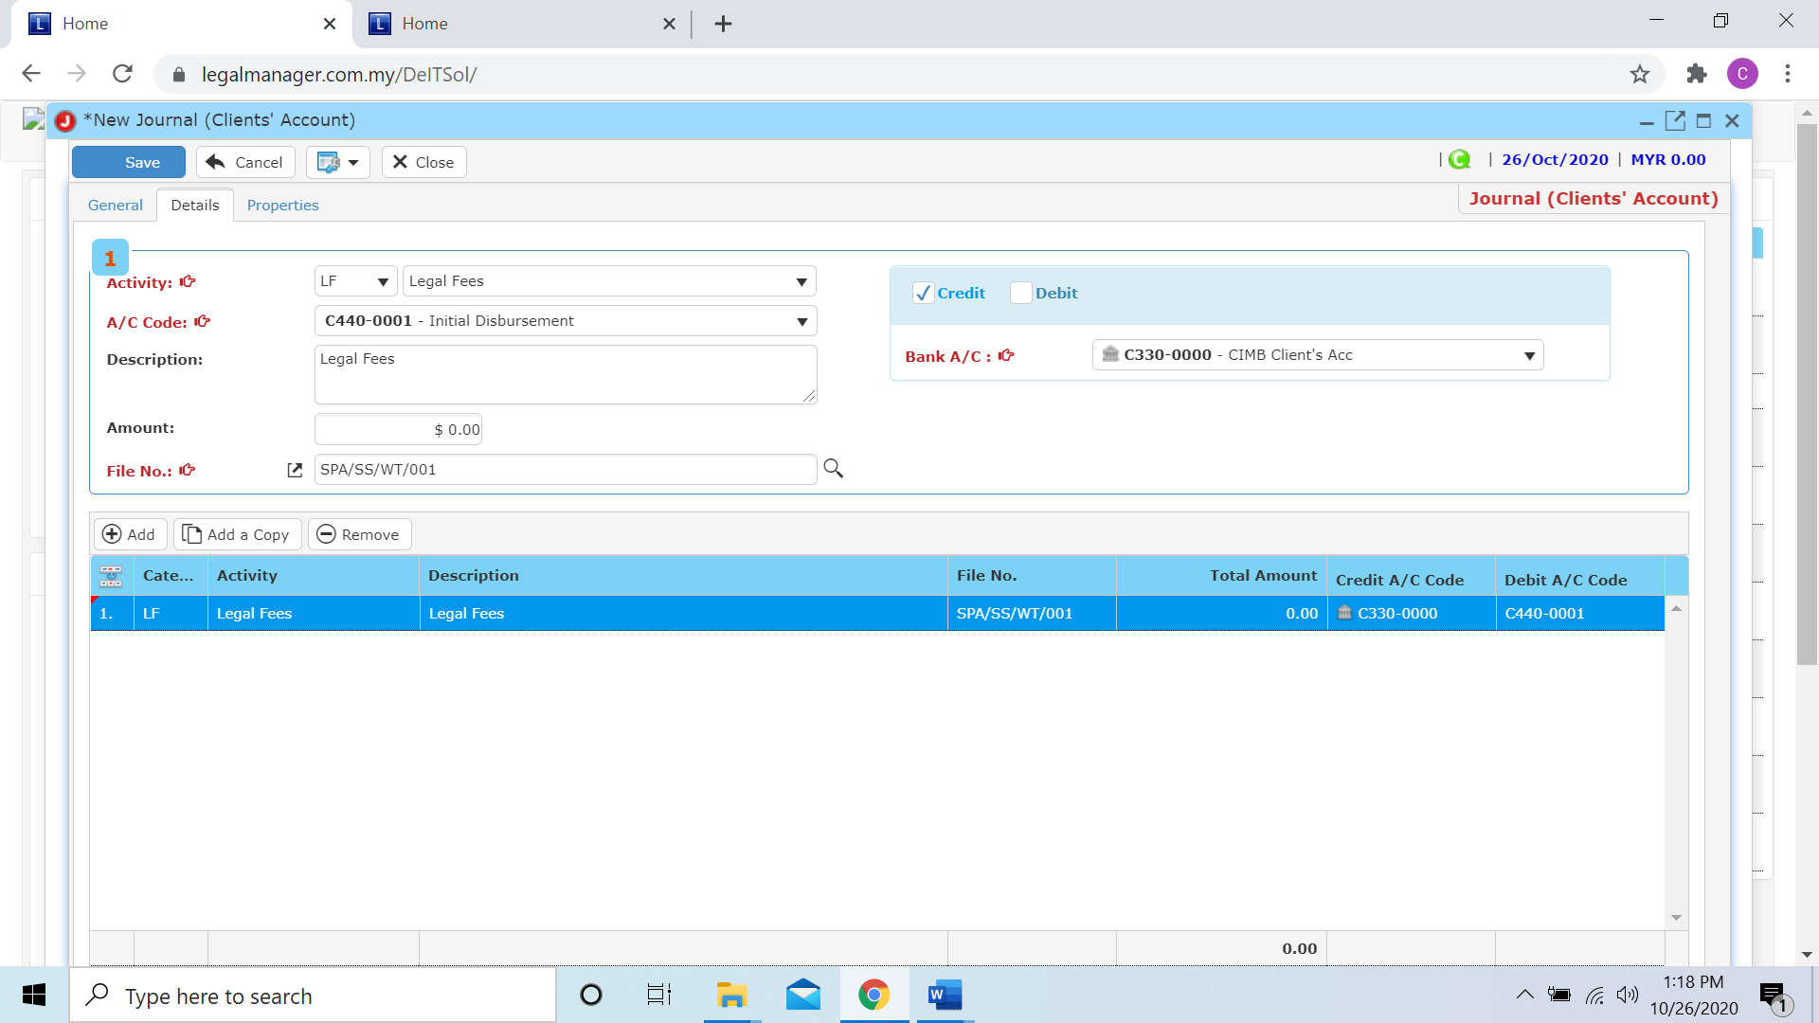

**Add**

* When you click ‘Add’ it will come out a new row and follow the process of above select and key in the activity.

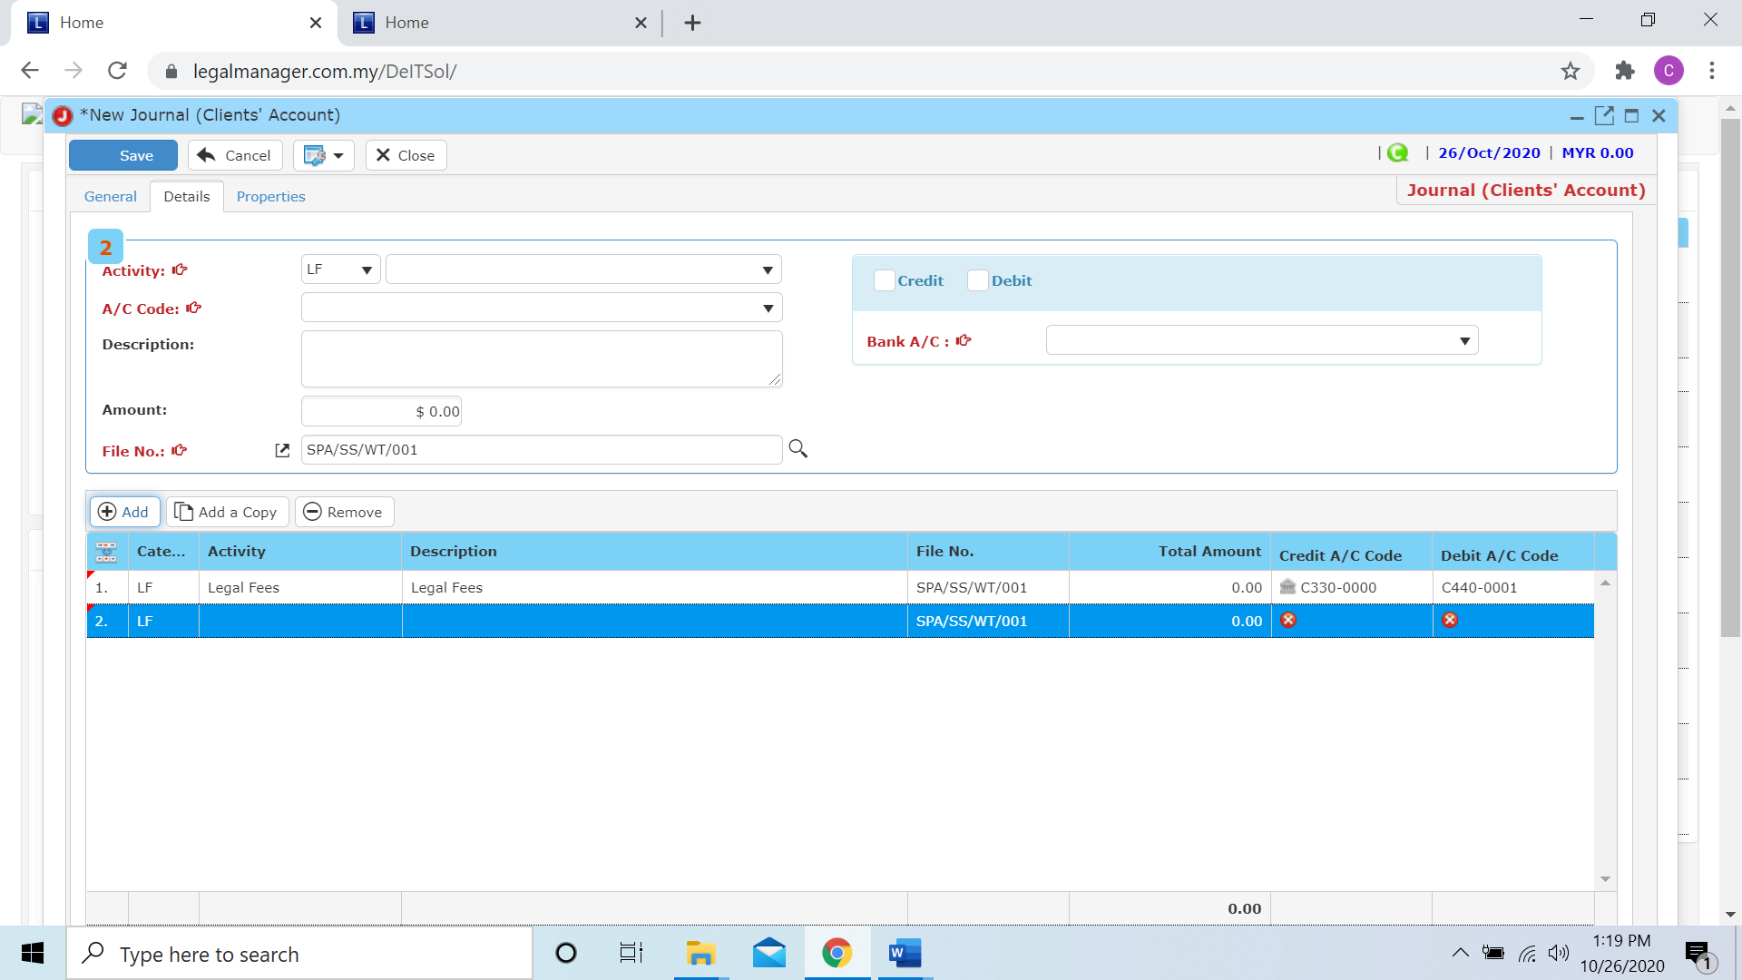

**Add a Copy**

* For Add a Copy, you can duplicate a selected row in the table

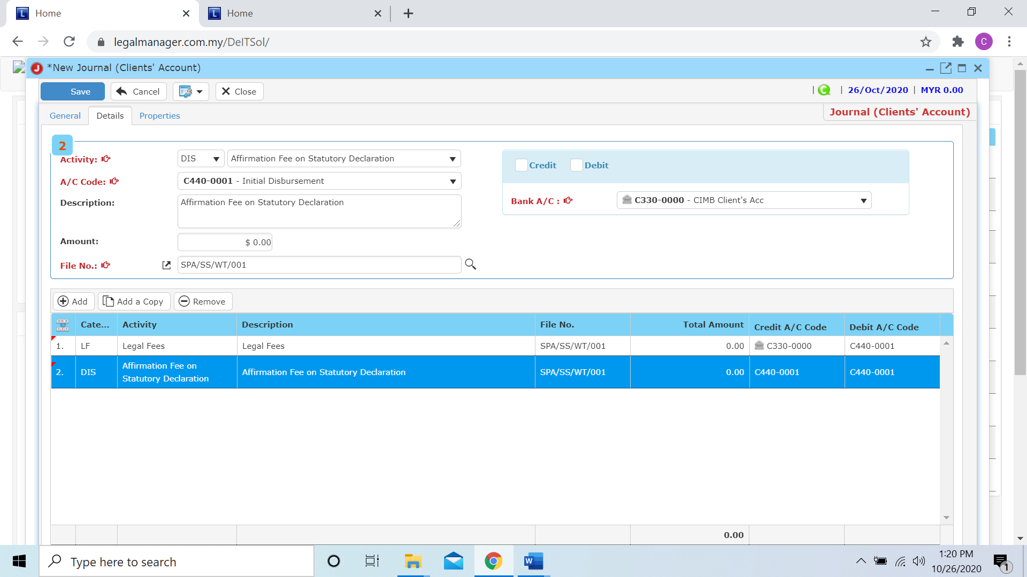

* After you click add a copy, it will copy the row as below figure shown

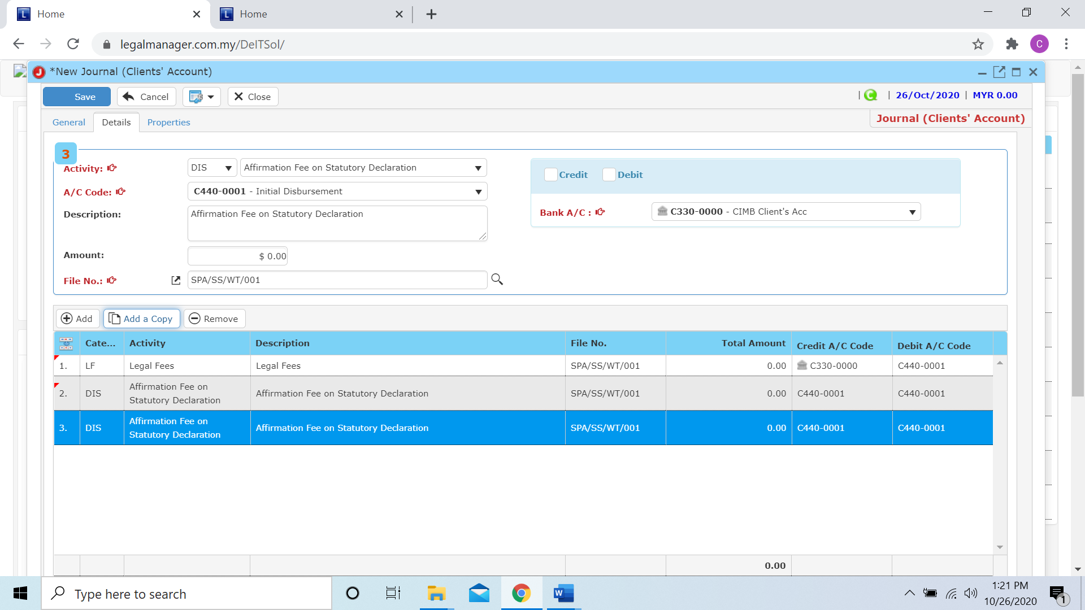

**Remove**

* For the remove, you have to select the bill in the list and click remove to erase the bill



* After you click the remove button it will erase the selected row



* When you finished in the details tab, you can click to the next tab ‘Properties’

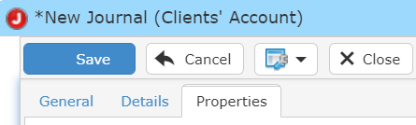

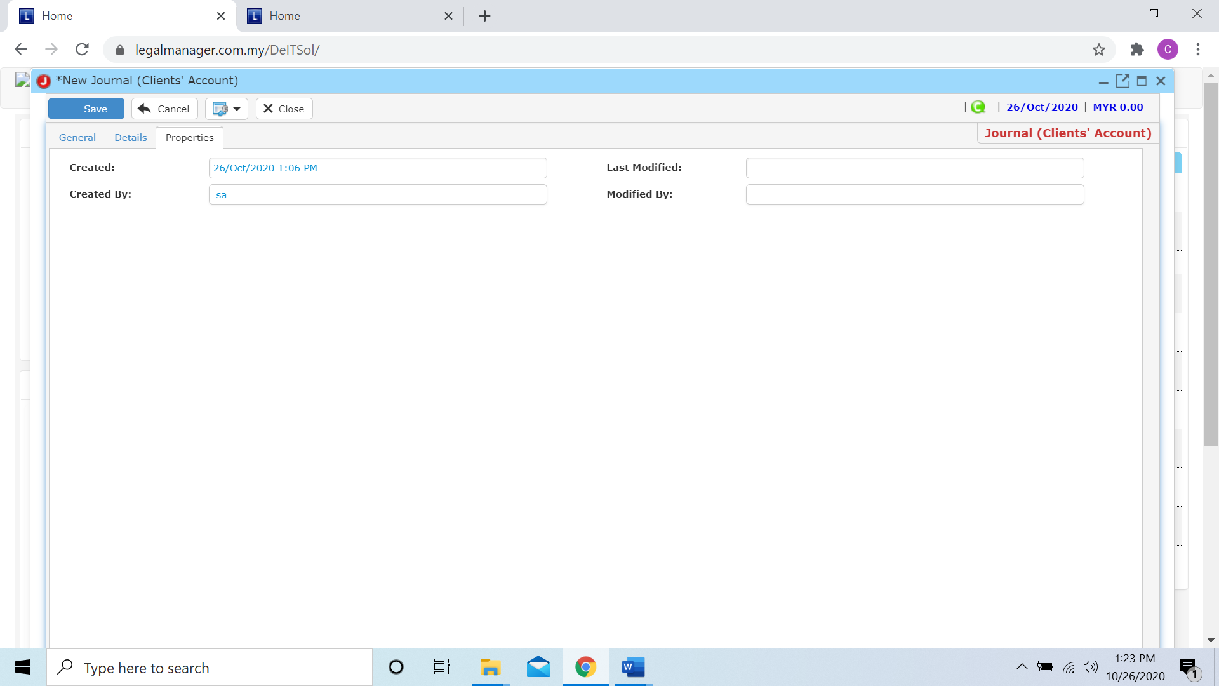

* You can view the information of the journal once who modify the journal then there will show the last modified and modified by who
* Once you finish all the instruction above, click ‘Save’ then you are done to create a new journal (clients’ account).

**10.4 Manage Journal (Clients’ Account)**

This option enables you to add, edit, and delete an clients’ account journal. It also allows you to keep track of your journal (clients’ account) details and all related information.

* To open Manage Journal (Clients’ Account), on the **SmartLeg@l** navigation, click **G/L** and go to **Manage Journal (Clients’ Account)** then search the journal you wish to modify.

**Manage Journal (Clients’ Account)**

* Search the journal you wish to manage through type the search criteria or search by advanced.
* To start a new search or to clear the search results, click ‘**Clear**’.

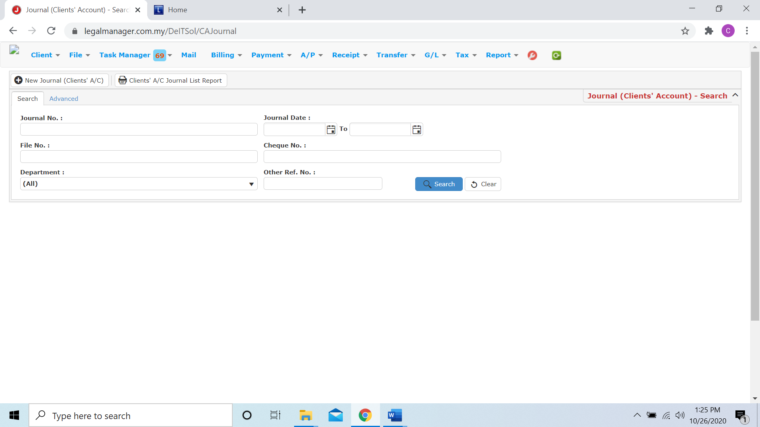

Figure: Manage Journal (Clients’ Account) - Search

**Advanced Search**

* This function can be used to find a journal by searching other information that is not captured in the ‘General’ section.
* Define search criteria:

**- Field** - Choose the field you want to search.

**- Condition** - Search condition

**- Value** - Type in the detail you want to find.

* Click ‘**Add to list**’, to define more than one criteria.
* Click ‘**Find**’, search results will be displayed at search record list. You can open an item in the search results list by double-clicking.
* To start a new search or to clear the search results, click ‘**Clear**’.
* Click ‘**Export**’ to print the desired search results in txt, excel or html format.

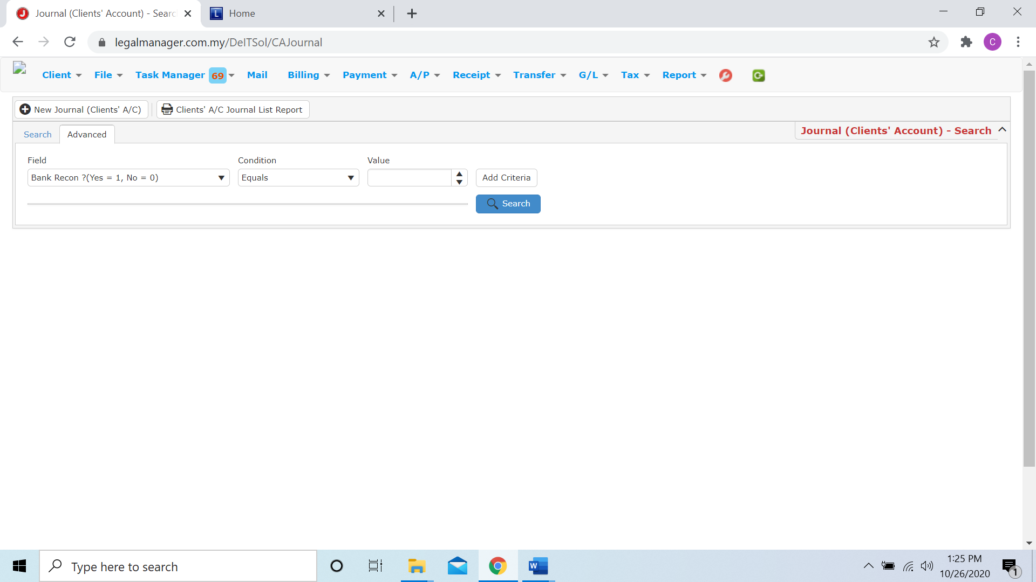

Figure: Manage Journal (Clients’ Account)– Advanced Search

* You can choose to create a new journal (clients’ a/c) by click  and refer to ‘Chapter 10.3 New Journal (Clients’ Account)’
* You can print or preview the Clients’ A/C Journal List Report while you click to 
* Then it will pop-up a Clients’ A/C Journal List Report you can insert your requirement and filter the report

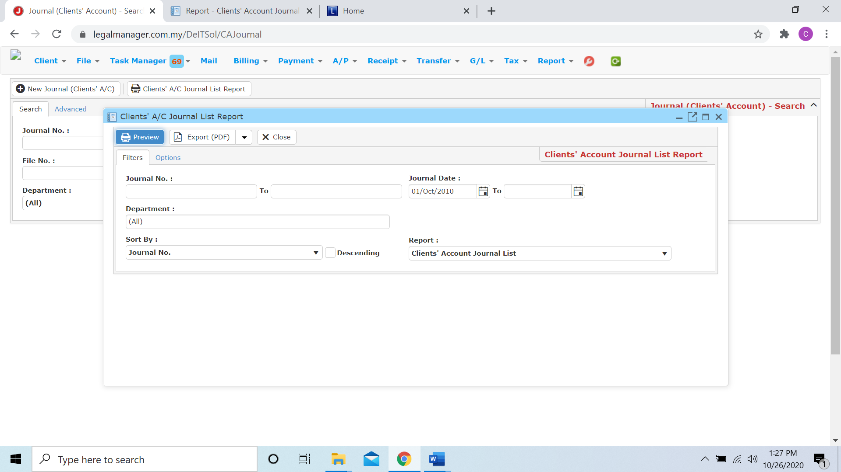

* Besides, you can preview the report as figure below shown

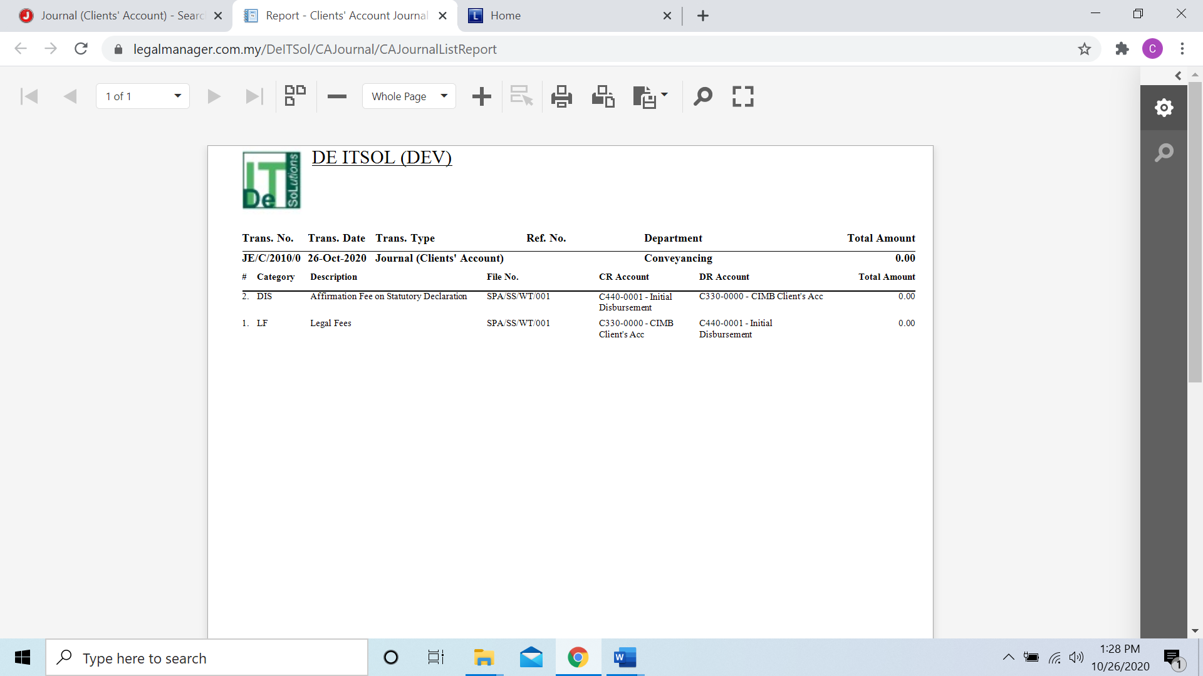

* You can also export the report into PDF or excel by clicking

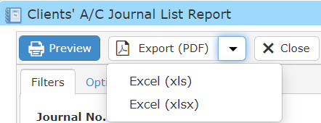

**Searched Result**

* Click ‘**Search**’ once, to show all journal of client account
* The Searched result will appeal at below, otherwise it will shown no record availble if the quotation you searched do not exist.
* Click ‘**Export**’ to print the desired search results in txt, excel or html format.

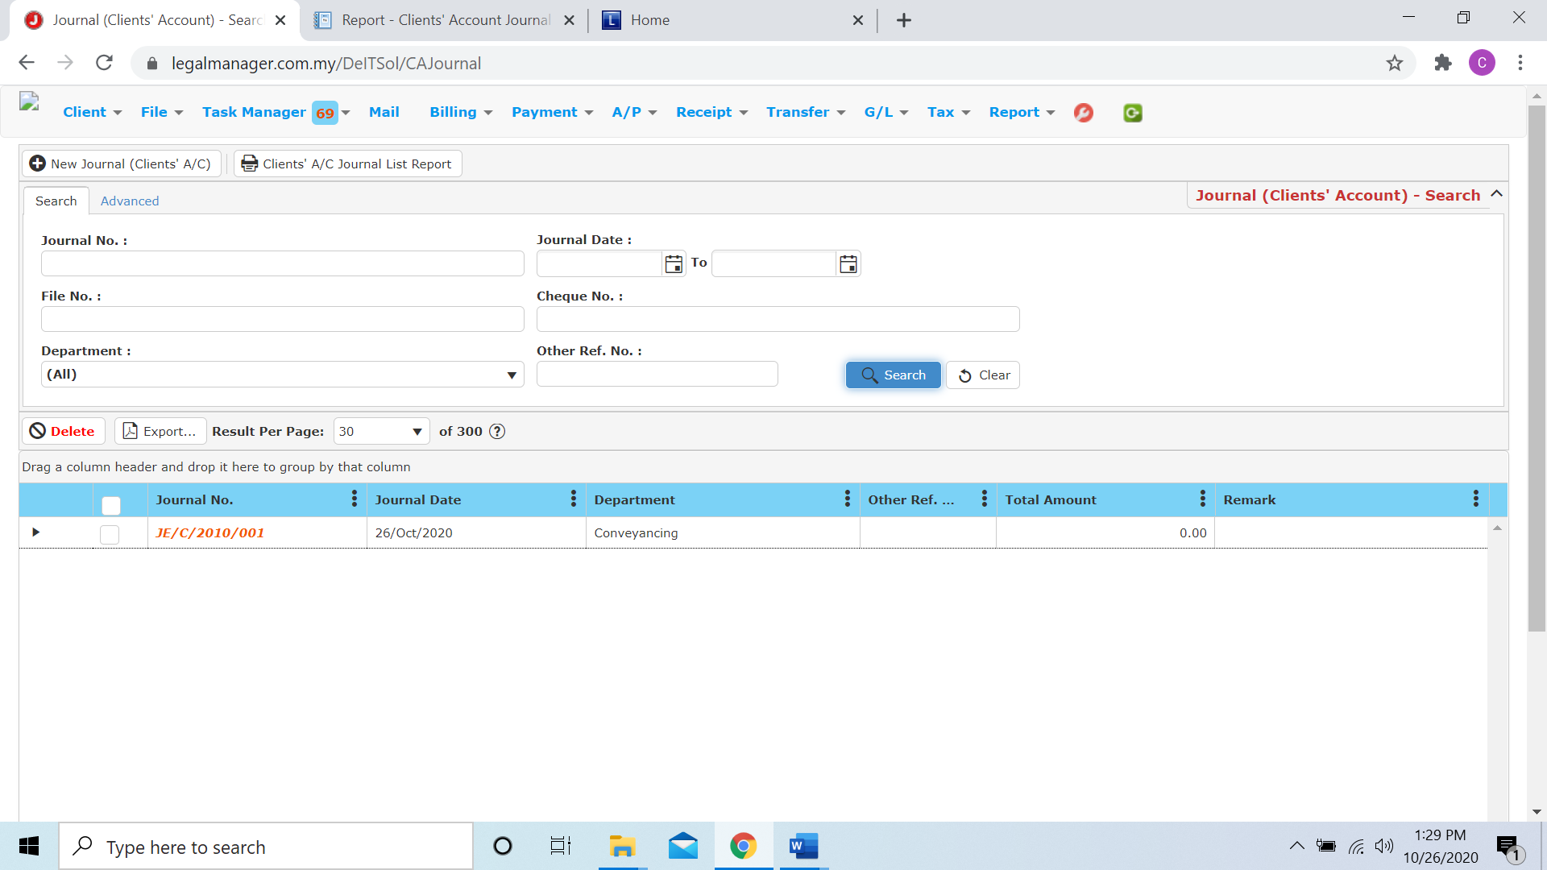

**10.5 Manage Bank Recon**

* To open Manage Bank Recon, on the **SmartLeg@l** navigation, click **G/L** and go to **Manage Bank Recon** then search the bank recon you wish to modify.

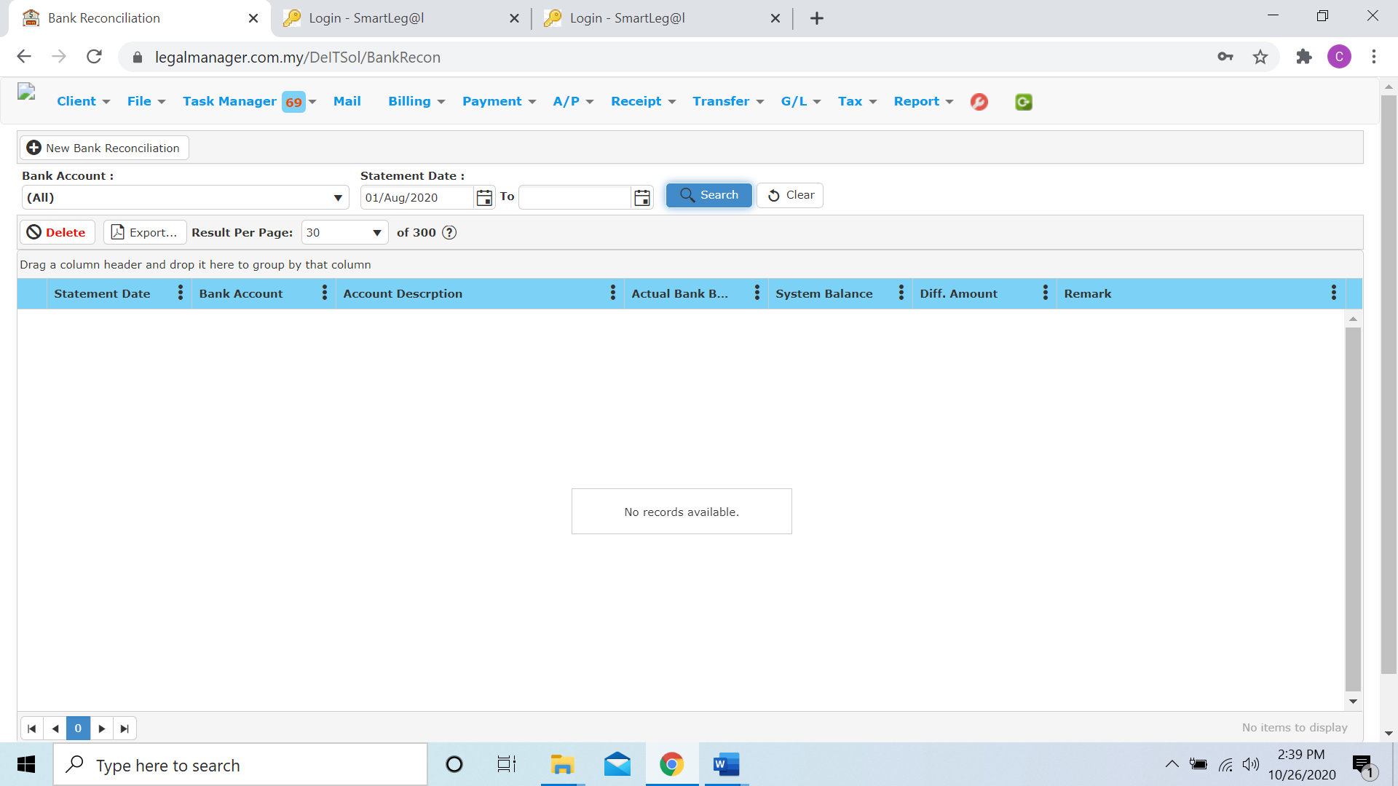

* You are allow to create new reconciliation by clicking 

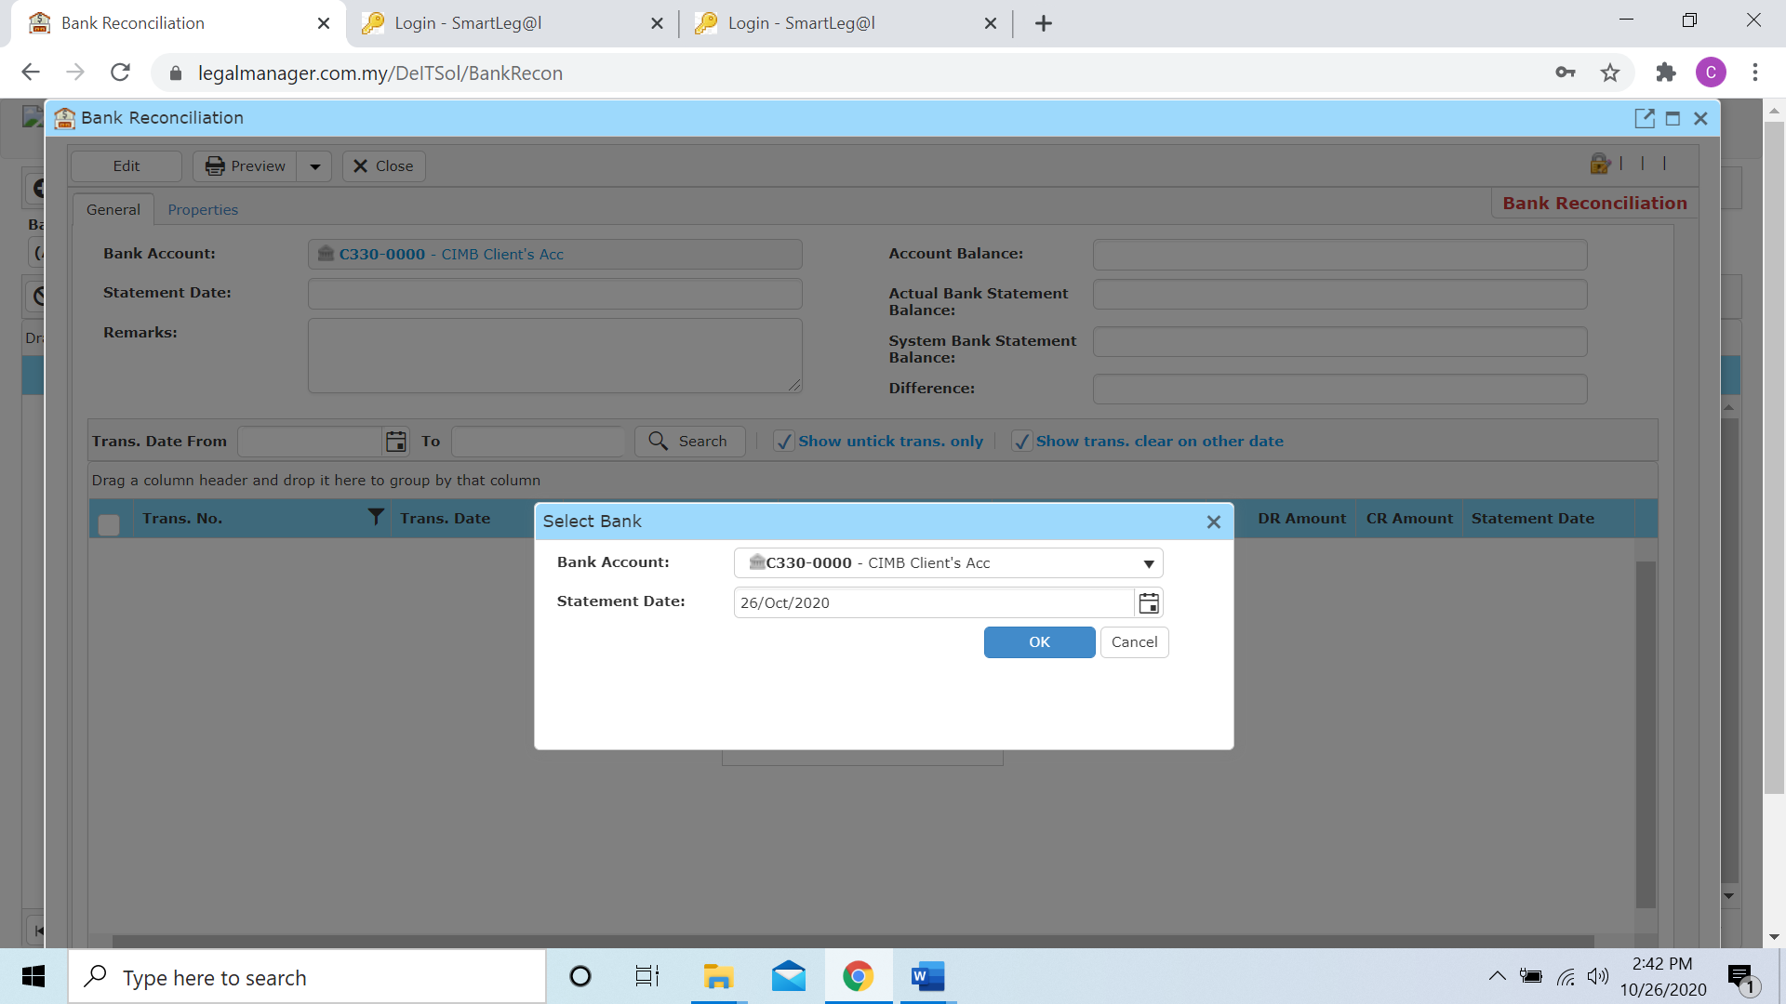

* When you click to the new reconciliation, it will pop-up to prompt user to select a bank account and statement date

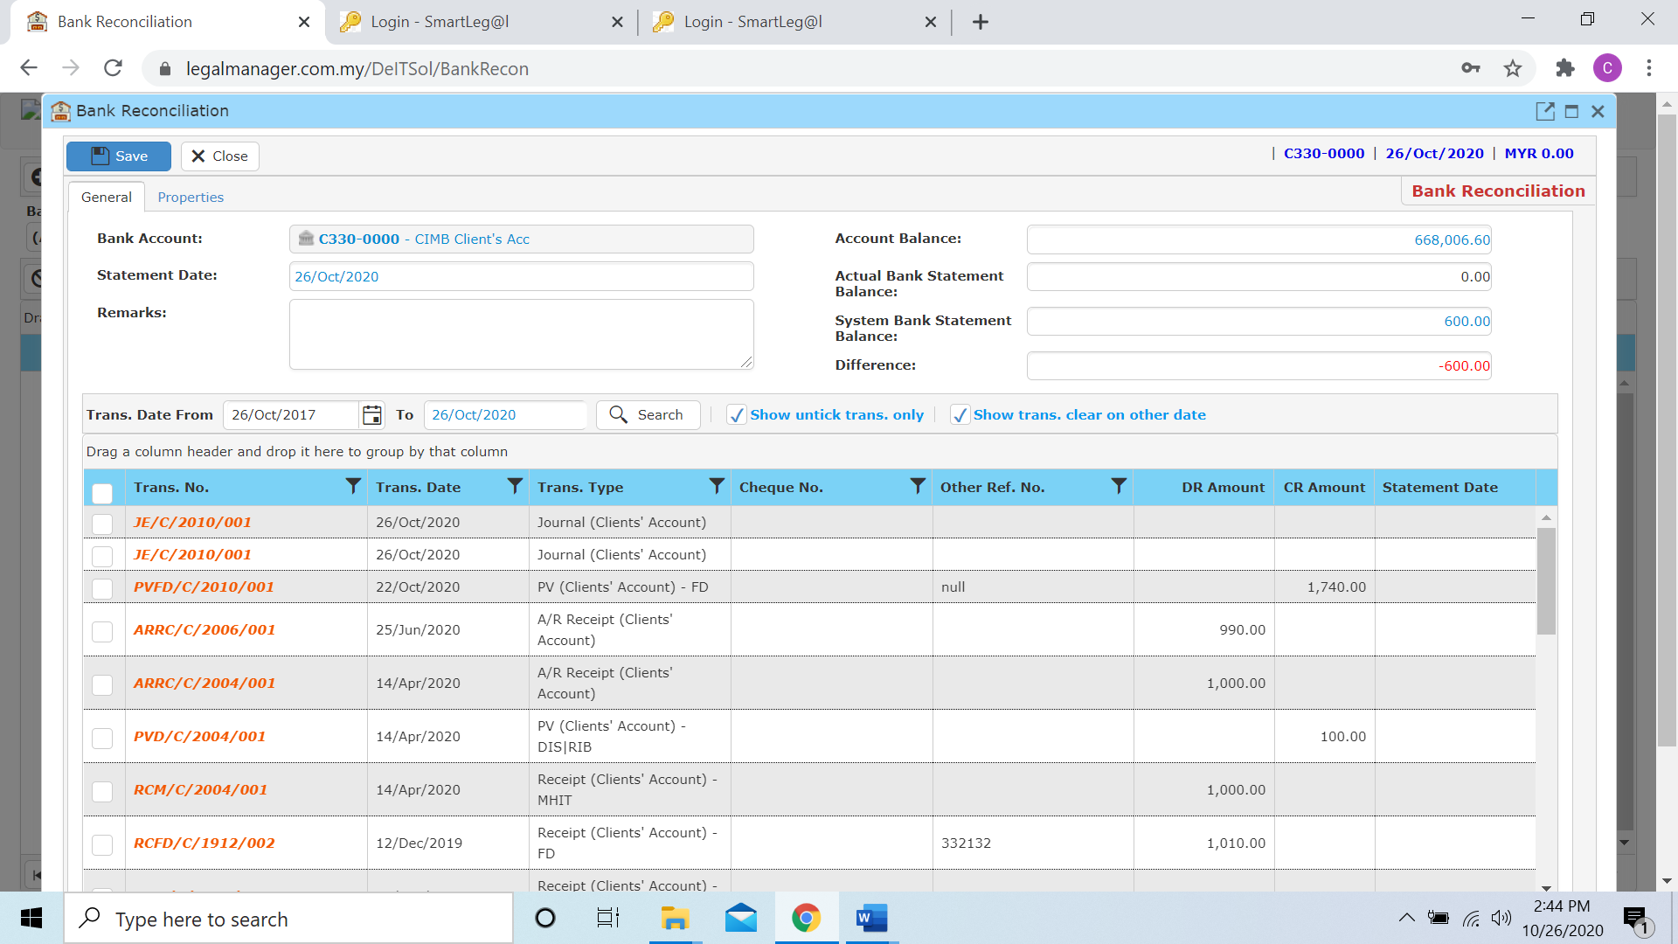

* Then you can select the record and view statement balances and differences instantly.

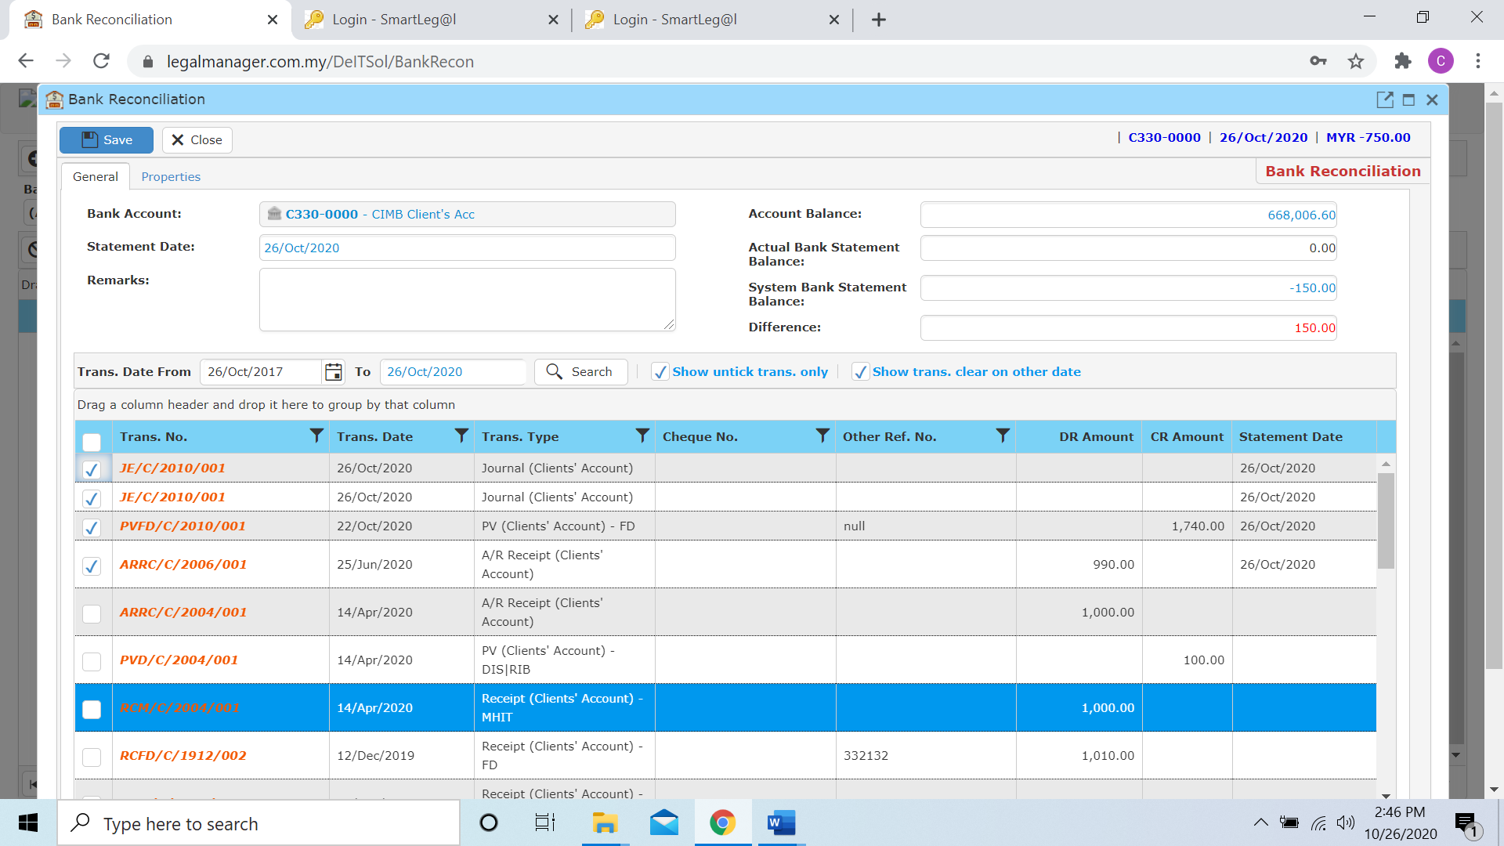

* After you finish, click to ‘Save’ it will show the bank recon in the search list of Manage Bank Recon

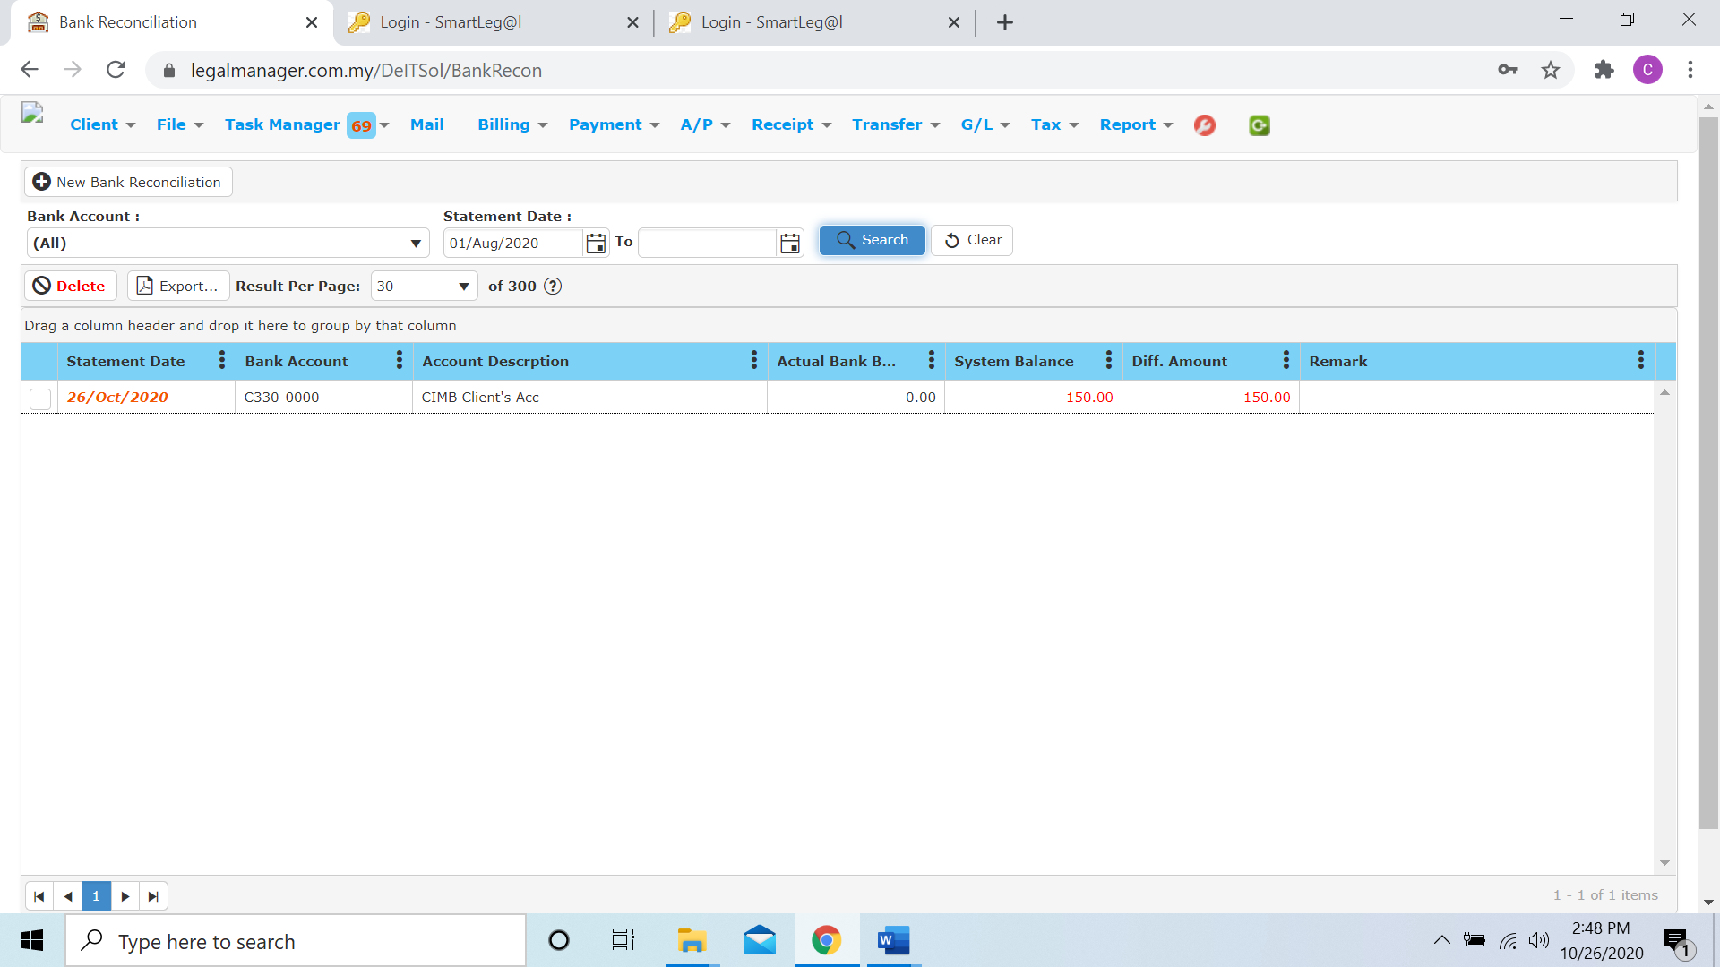

* Click ‘**Delete**’ to delete the selected bank recon
* Click ‘**Export**’ to print the desired search results in txt, excel or html format.

**10.6 New Unpresented Cheque (Office A/C)**

* To open New Invoice, on the **SmartLeg@l** navigation, click **G/L** and go to **New Unpresented Cheque (Office A/C)**

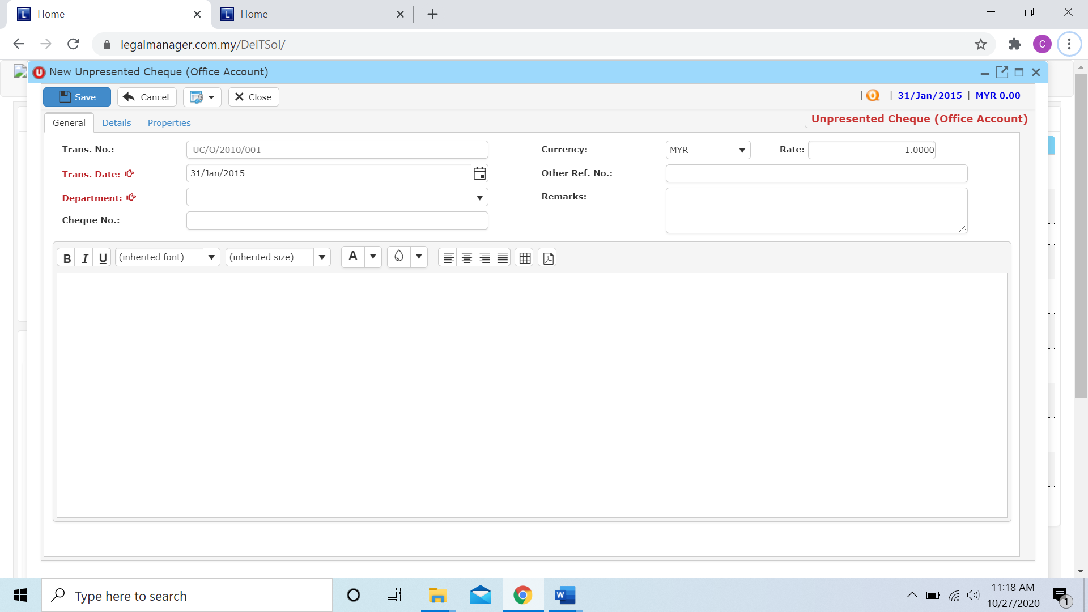

* After you enter and select Trans Date, Department and key in other related info you can click to the next tab ‘Details’

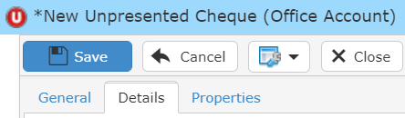

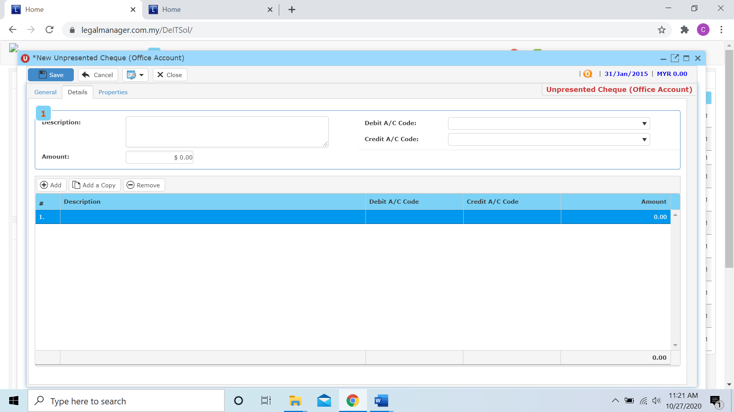

* The description and amount you entered and credit or debit acc code will shown inside the table below

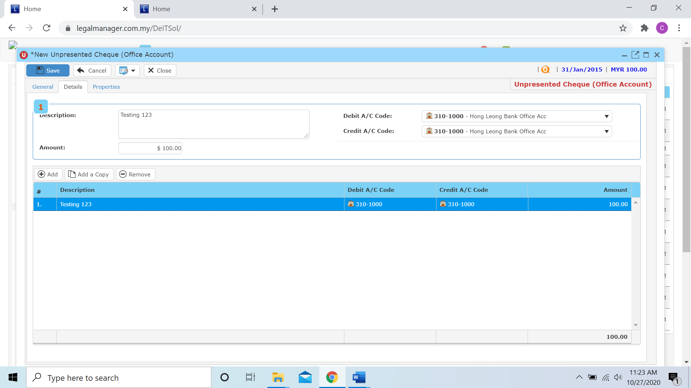

**Add**

* When you click ‘Add’ it will come out a new row and follow the process of above select trans acc and key in the description and amount.

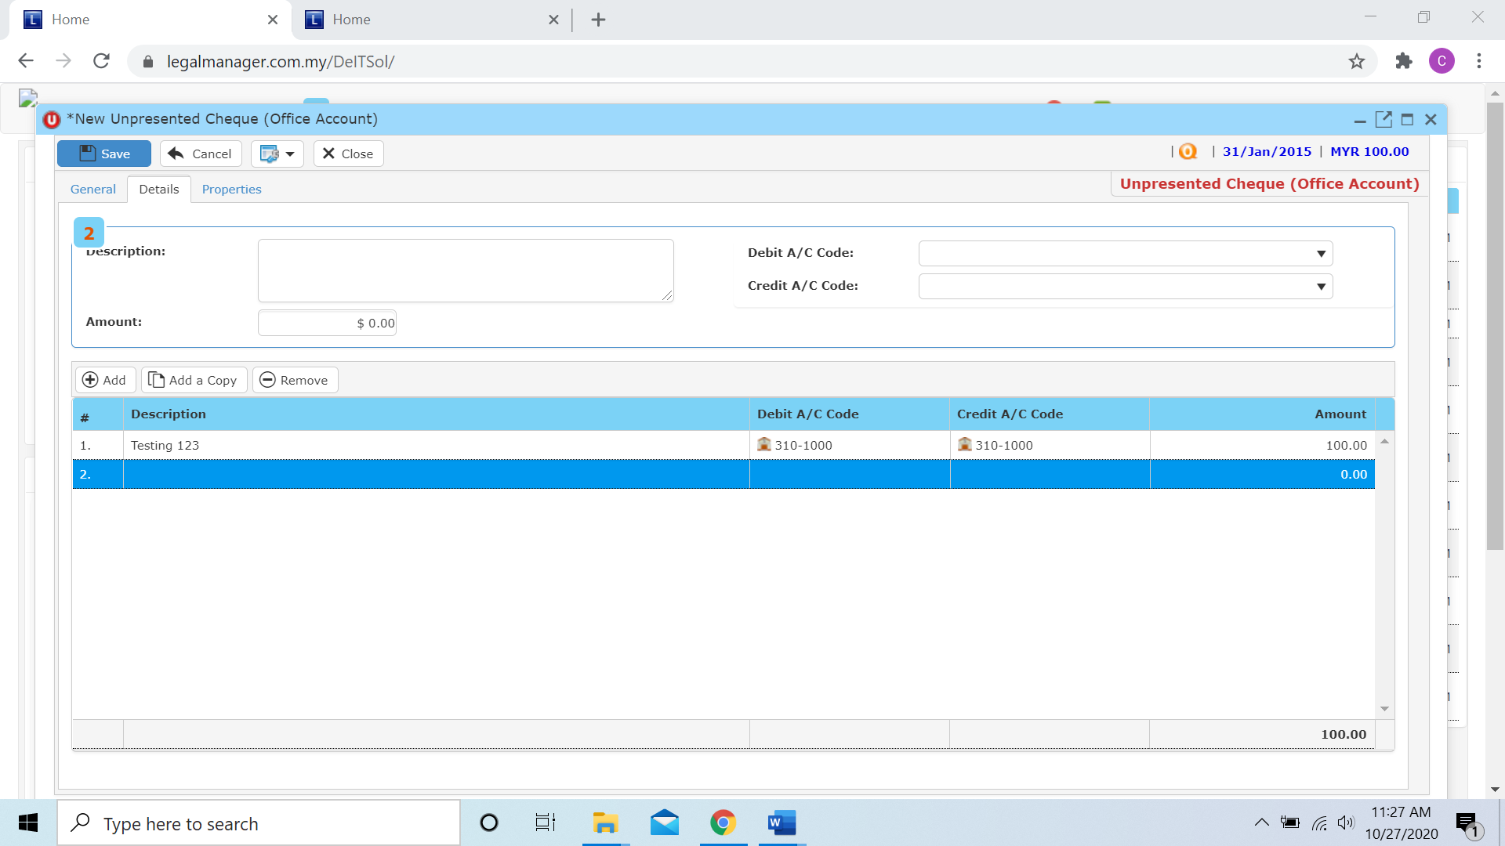

**Add a Copy**

* For Add a Copy, you can duplicate a selected row in the table

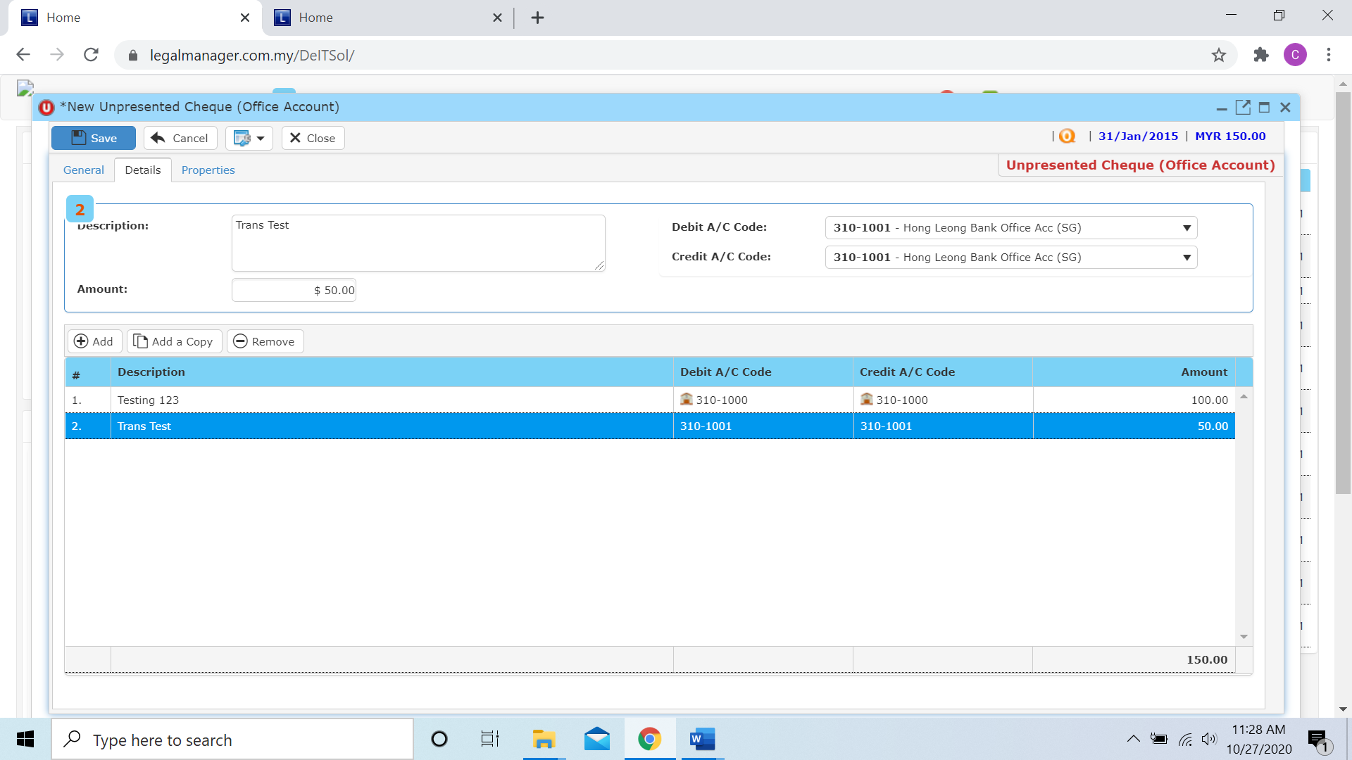

* After you click add a copy, it will copy the row as below figure shown

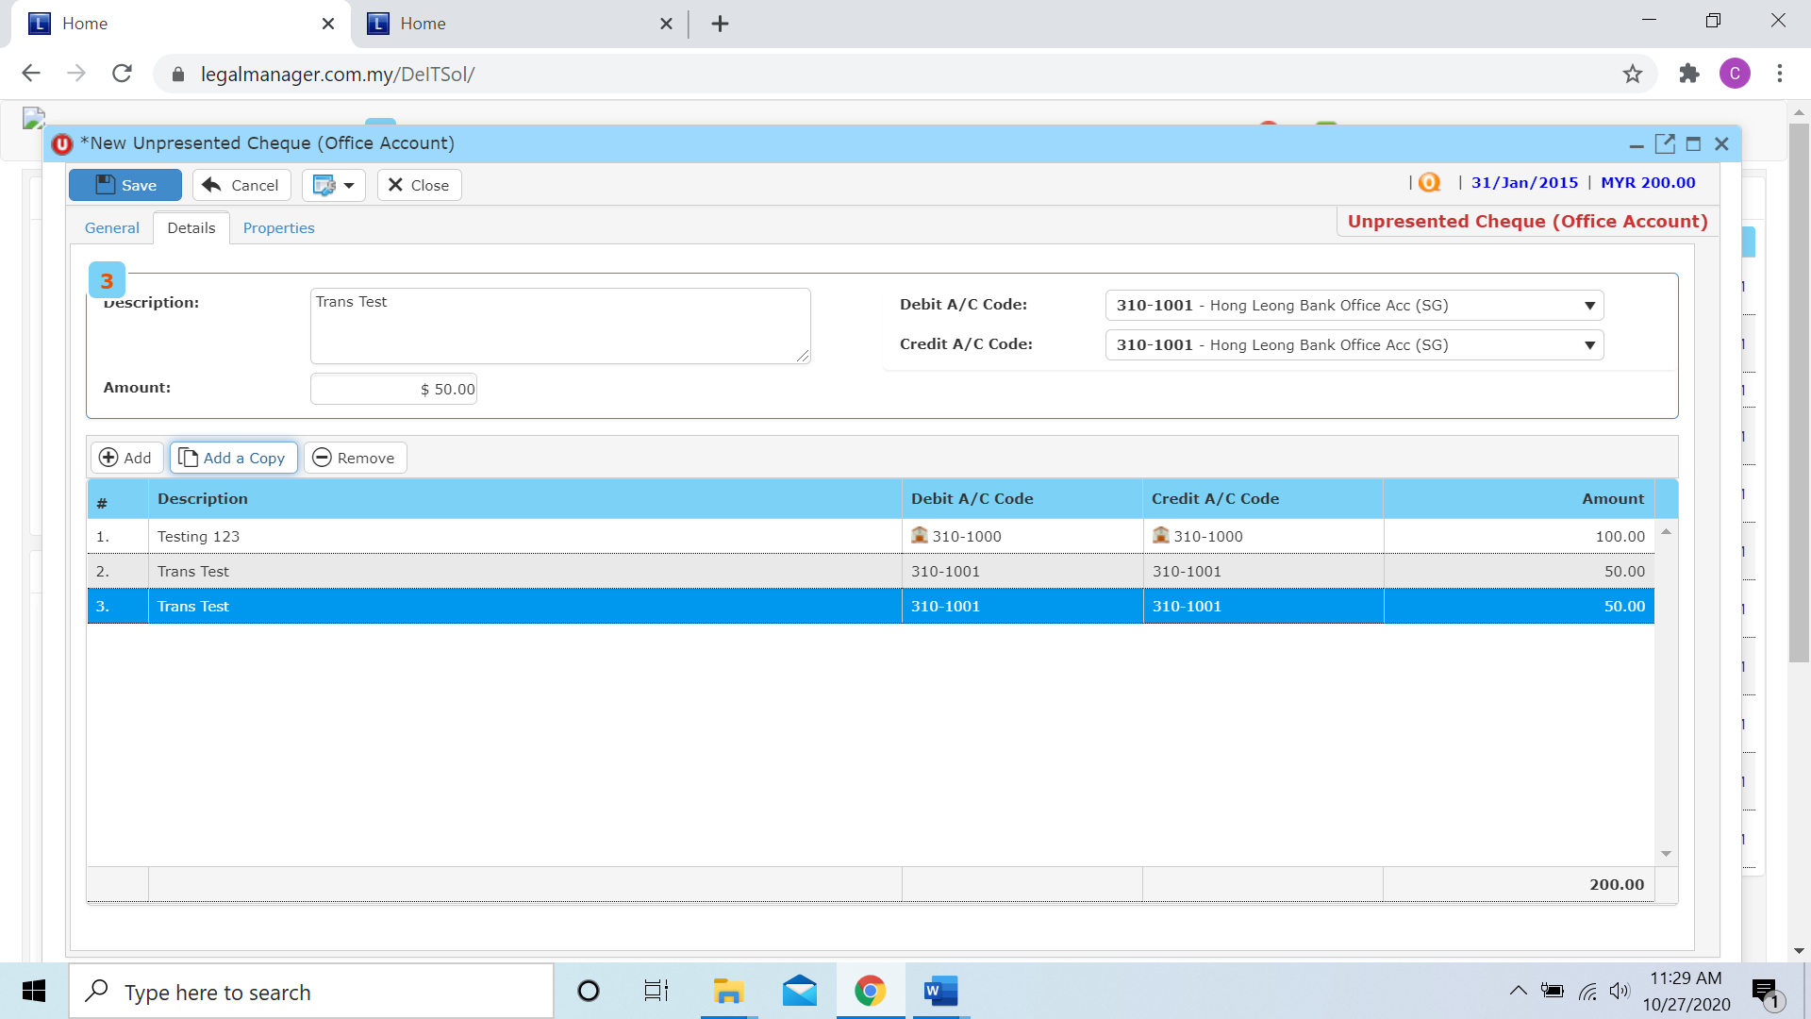

**Remove**

* For the remove, you have to select the bill in the list and click remove to erase the bill



* After you click the remove button it will erase the selected row



* When you finished in the details tab, you can click to the next tab ‘Properties’

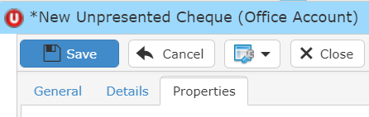

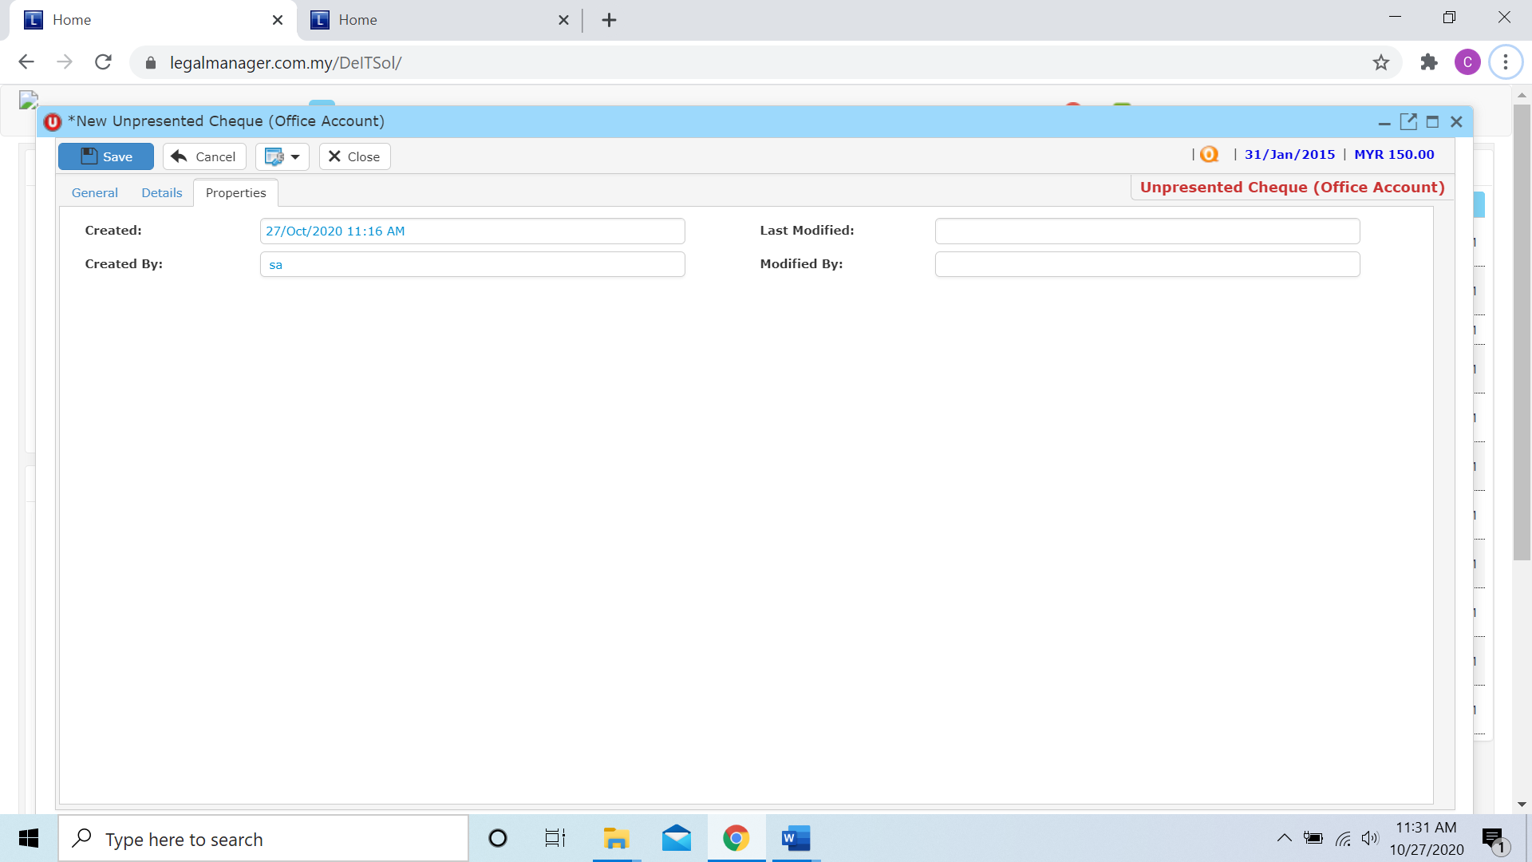

* You can view the information of the cheque once who modify the cheque then there will show the last modified and modified by who
* Once you finish all the instruction above, click ‘Save’ then you are done to create a new cheque.

**10.7 New Unpresented Cheque (Clients’ A/C)**

* To open New Invoice, on the **SmartLeg@l** navigation, click **G/L** and go to **New Unpresented Cheque (Clients’ A/C)**

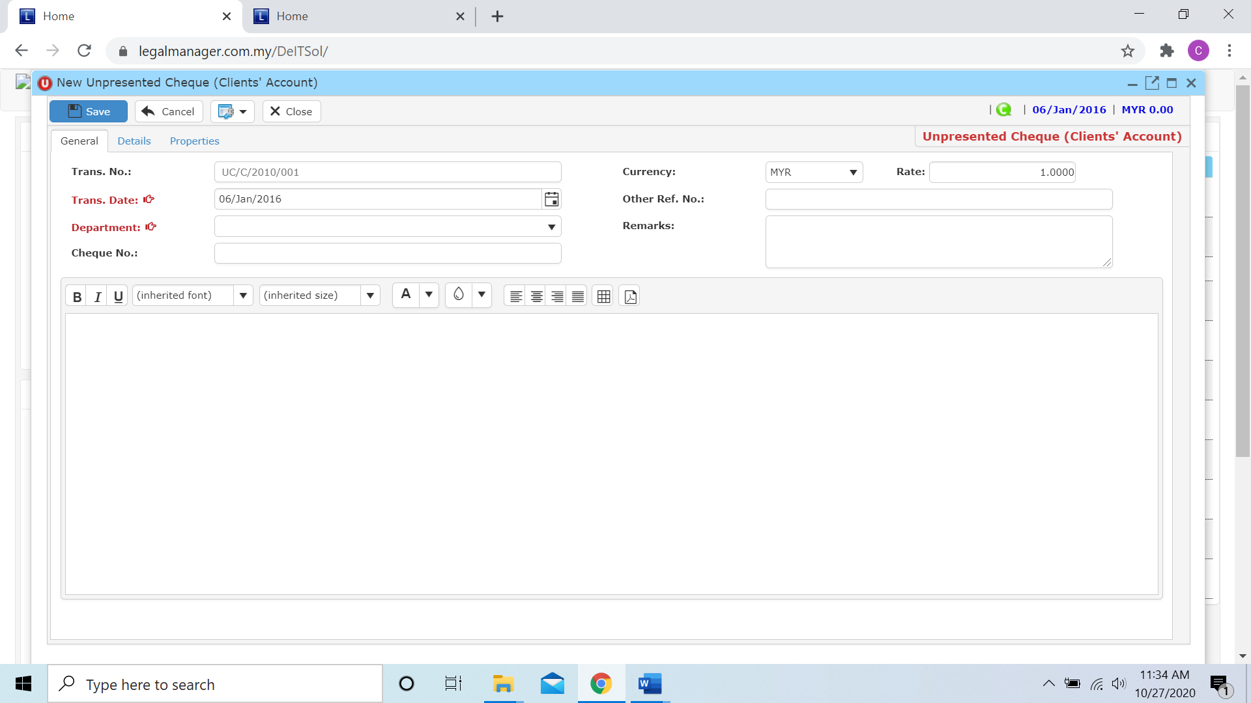

* After you enter and select Trans Date, Department and key in other related info you can click to the next tab ‘Details’

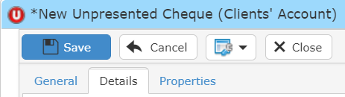

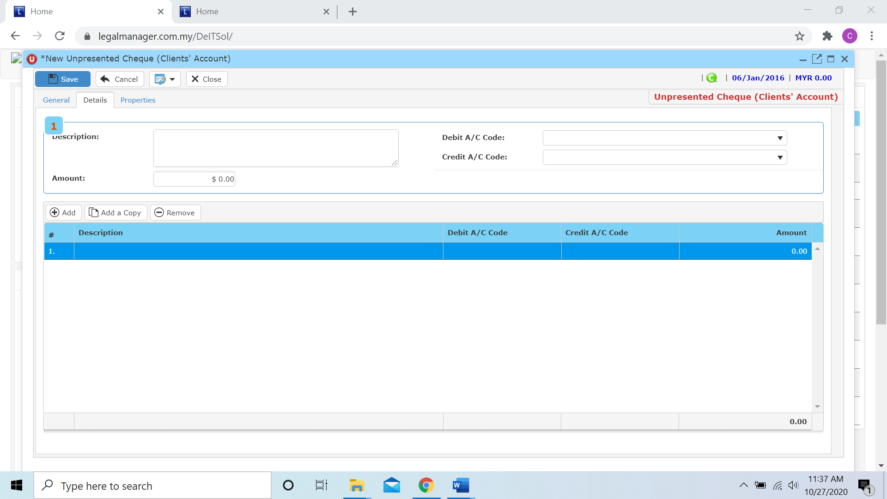

* The description and amount you entered and credit or debit acc code will shown inside the table below

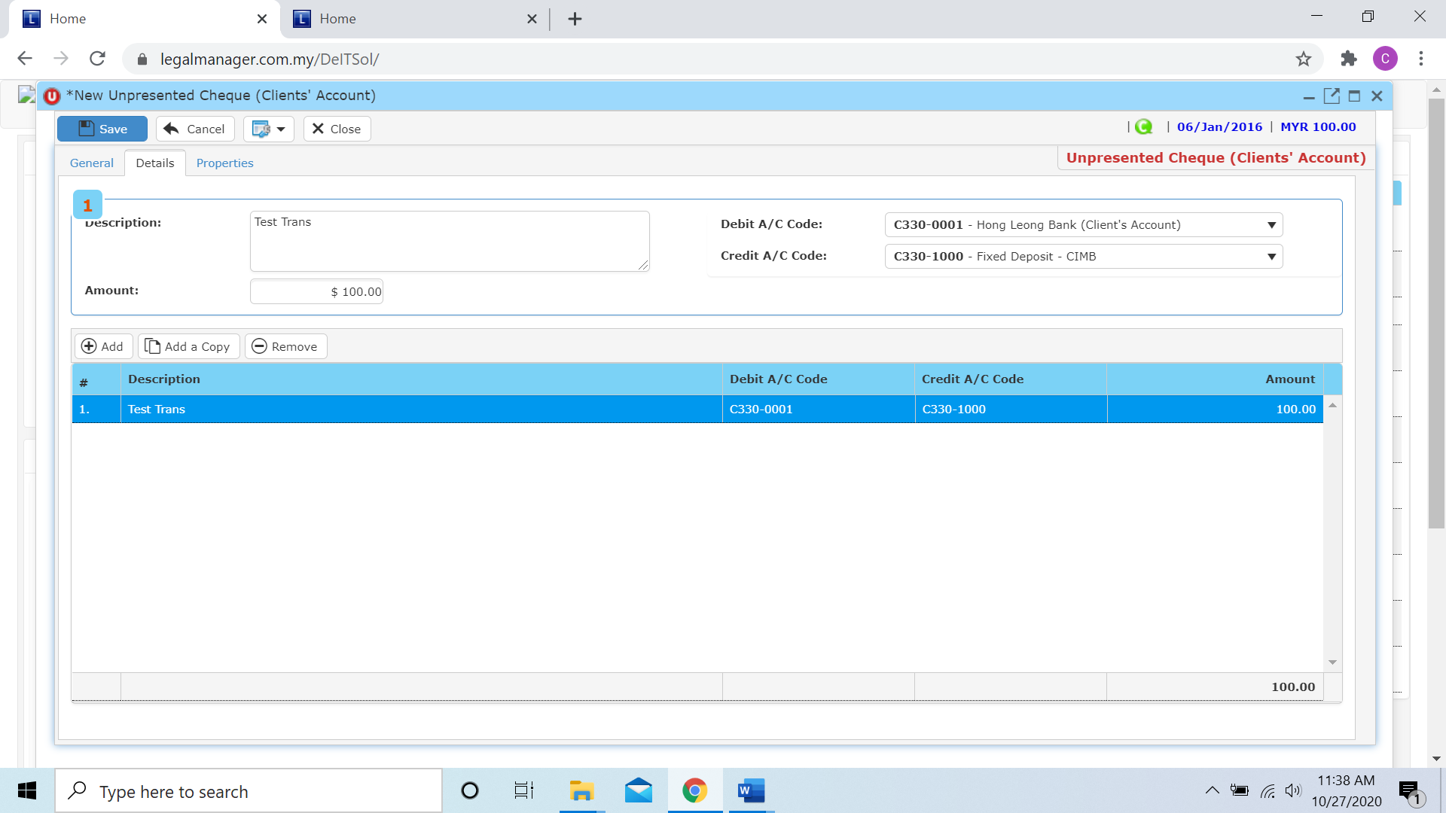

**Add**

* When you click ‘Add’ it will come out a new row and follow the process of above select trans acc and key in the description and amount.

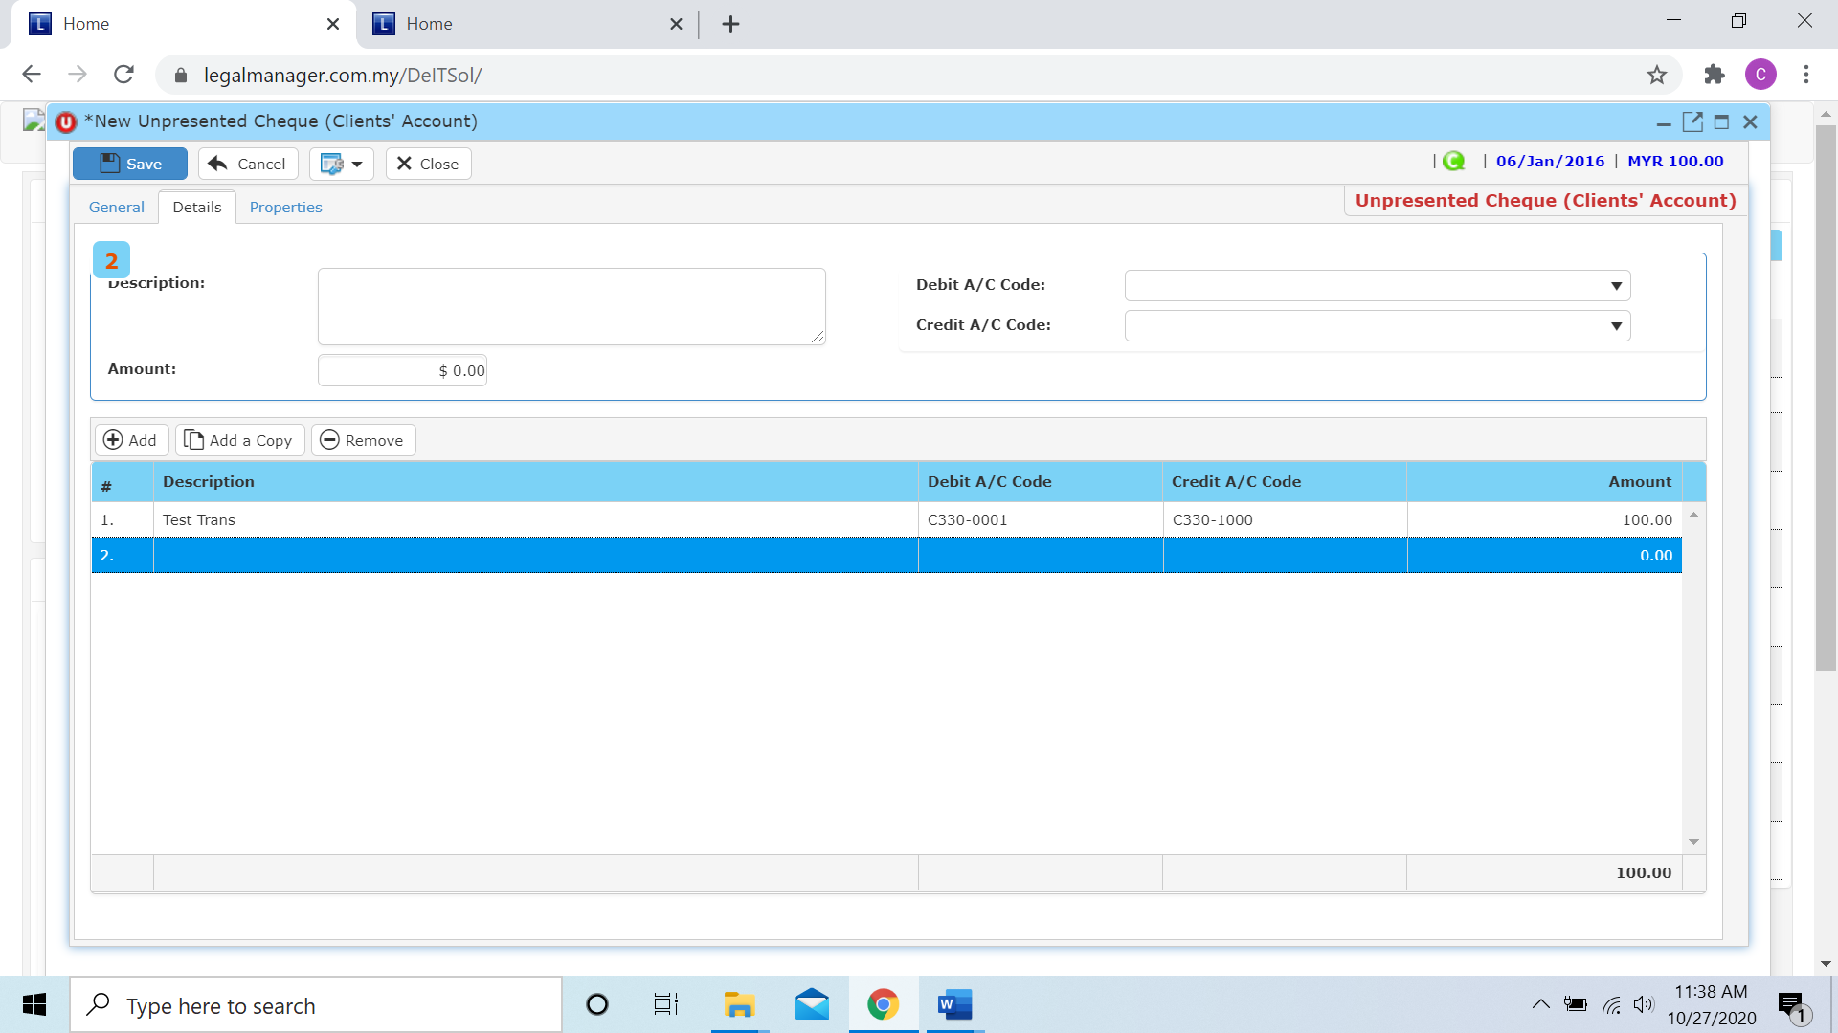

**Add a Copy**

* For Add a Copy, you can duplicate a selected row in the table

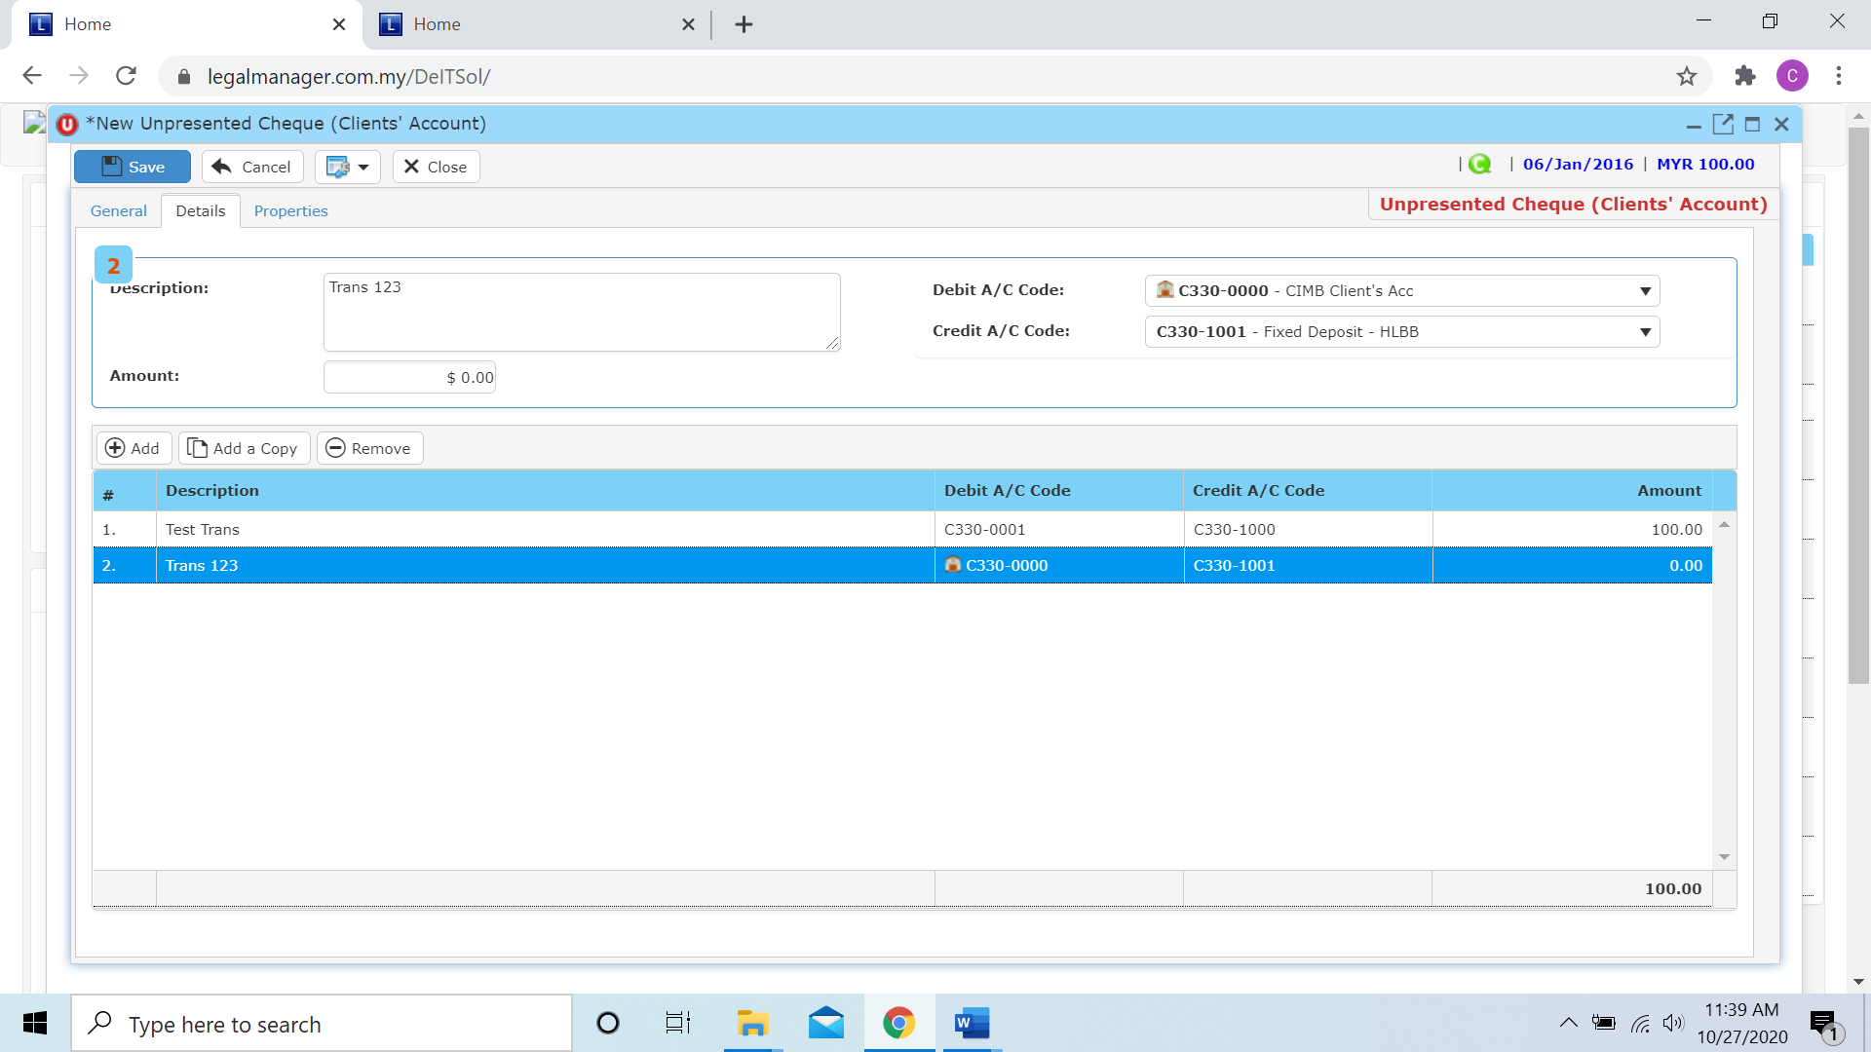

* After you click add a copy, it will copy the row as below figure shown

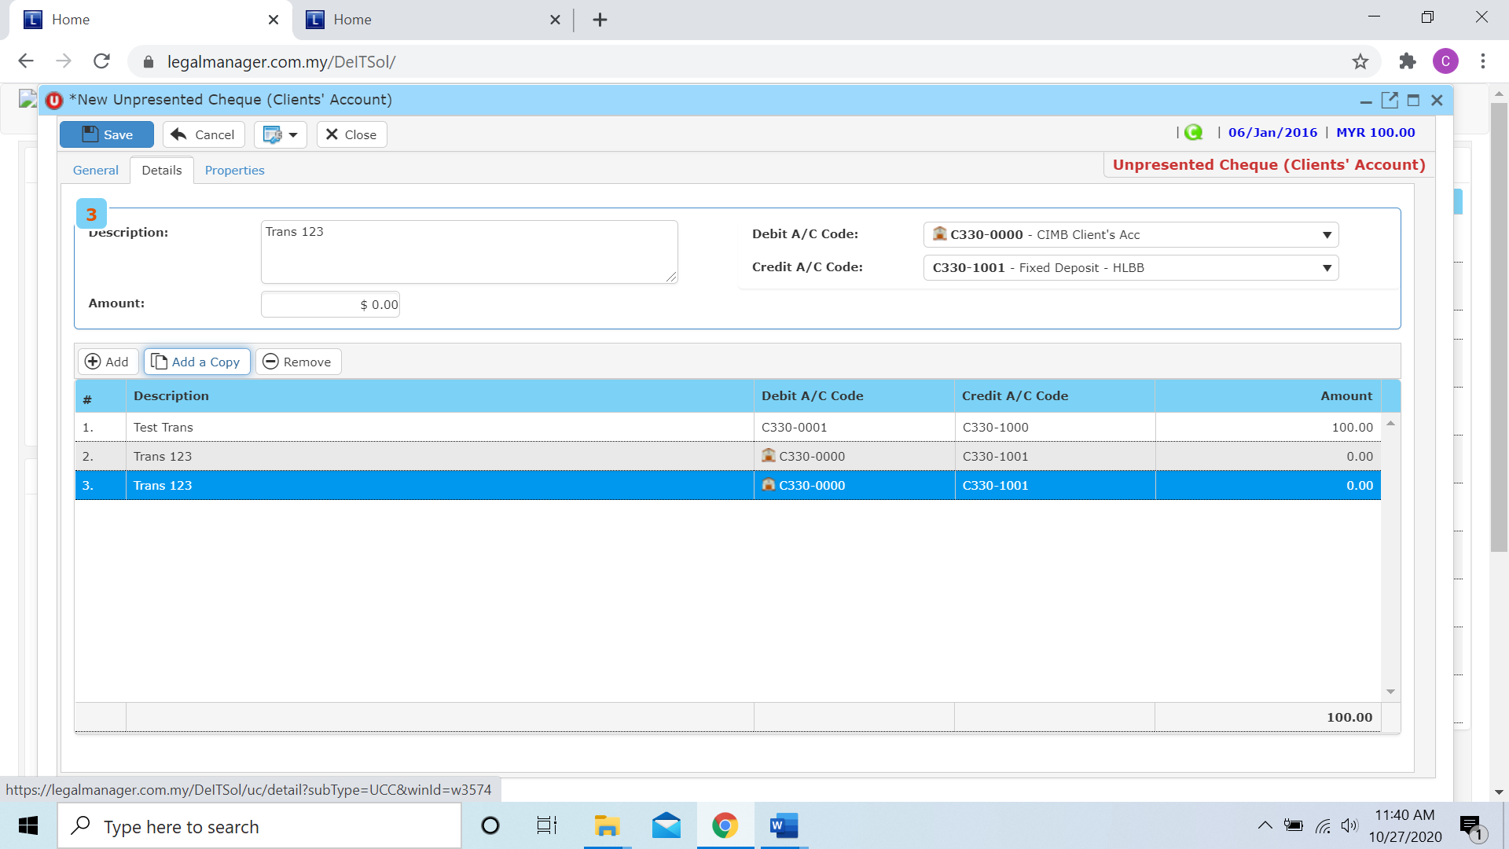

**Remove**

* For the remove, you have to select the bill in the list and click remove to erase the bill



* After you click the remove button it will erase the selected row



* When you finished in the details tab, you can click to the next tab ‘Properties’

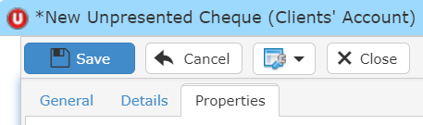

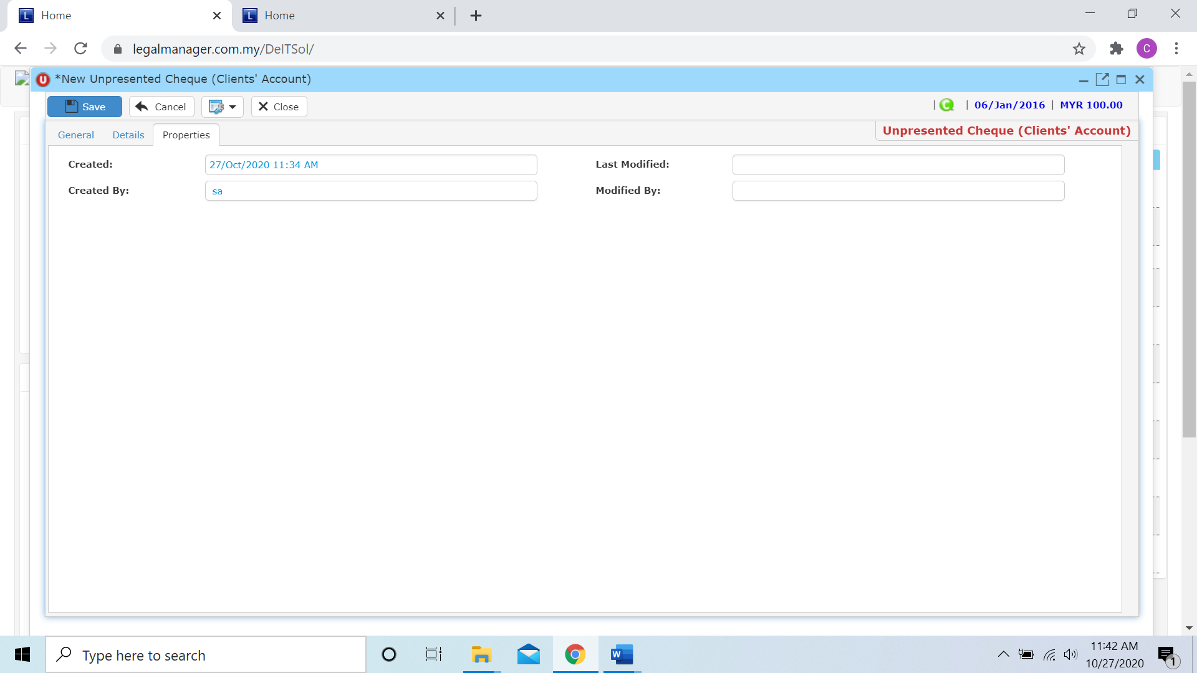

* You can view the information of the cheque once who modify the cheque then there will show the last modified and modified by who
* Once you finish all the instruction above, click ‘Save’ then you are done to create a new cheque.

**10.8 Manage Unpresented Cheque**

This option enables you to add, edit, and delete an cheque. It also allows you to keep track of your cheque details and all related information.

* To open Manage Unpresented Cheque, on the **SmartLeg@l** navigation, click **G/L** and go to **Manage Unpresented Cheque** then search the cheque you wish to modify.

**Manage Unpresented Cheque**

* Search the invoice you wish to manage through type the search criteria or search by advanced.
* To start a new search or to clear the search results, click ‘**Clear**’.

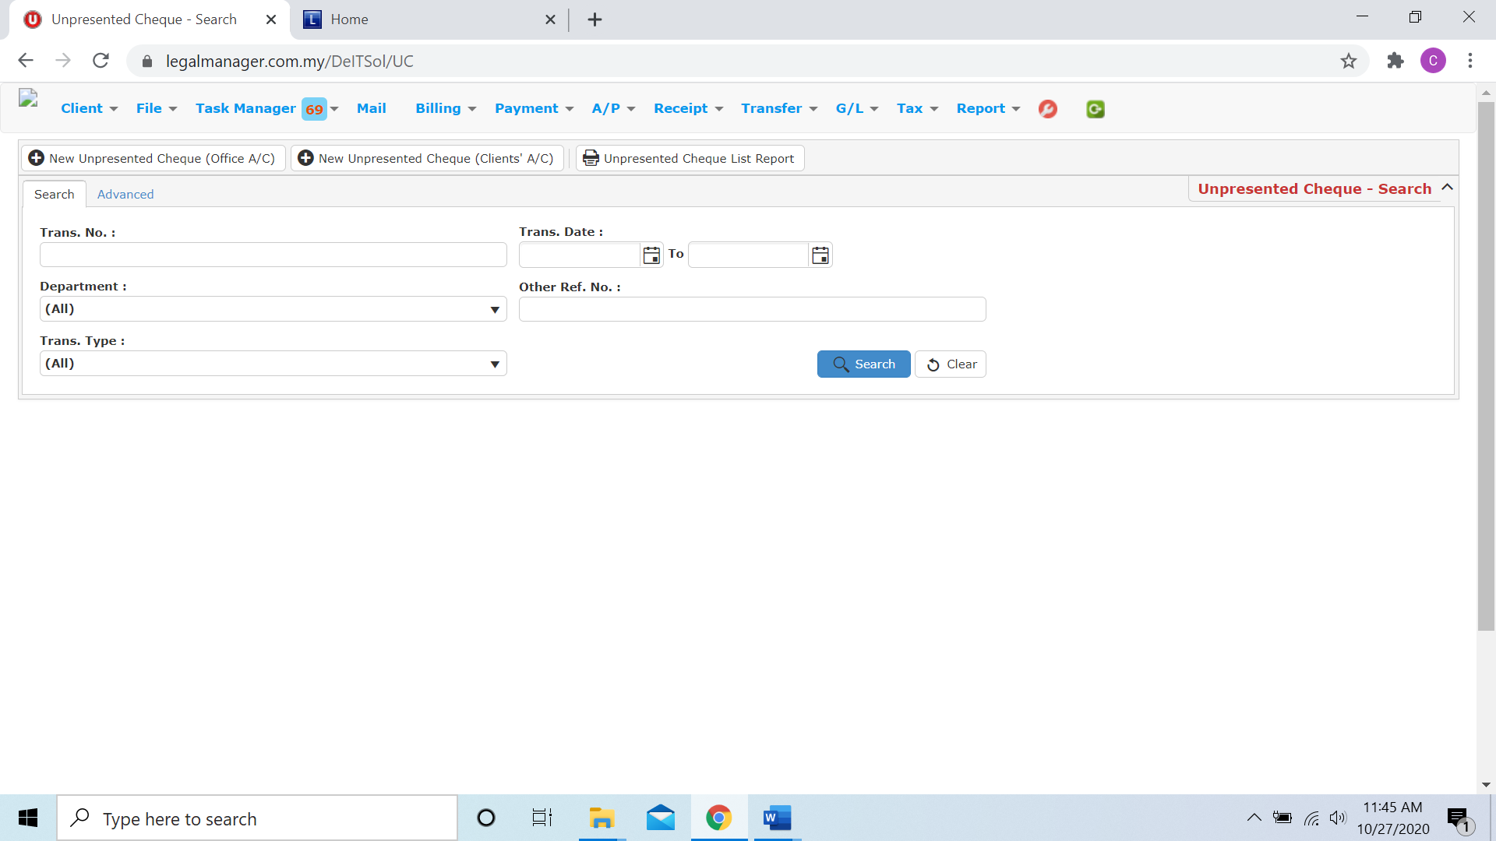

Figure: Manage Unpresented Cheque - Search

**Advanced Search**

* This function can be used to find a cheque by searching other information that is not captured in the ‘General’ section.
* Define search criteria:

**- Field** - Choose the field you want to search.

**- Condition** - Search condition

**- Value** - Type in the detail you want to find.

* Click ‘**Add to list**’, to define more than one criteria.
* Click ‘**Find**’, search results will be displayed at search record list. You can open an item in the search results list by double-clicking.
* To start a new search or to clear the search results, click ‘**Clear**’.
* Click ‘**Export**’ to print the desired search results in txt, excel or html format.

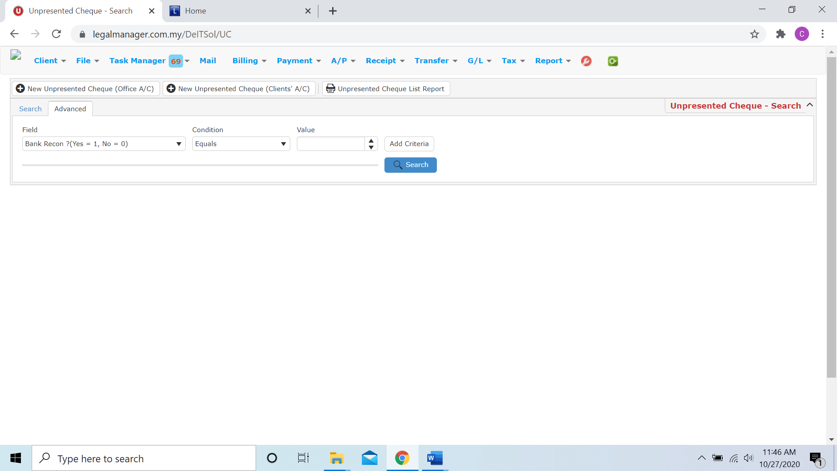

Figure: Manage Unpresented Cheque– Advanced Search

* You can choose to create a new unpresented cheque for office a/c by click  and refer to ‘Chapter 10.6 New Unpresented Cheque (Office A/C)’
* You can choose to create a new unpresented cheque for clients’ a/c by click 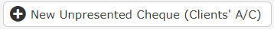 and refer to ‘Chapter 10.7 New Unpresented Cheque (Clients’ A/C)’
* You can print or preview the Unpresented Cheque List Report while you click to 
* Then it will pop-up a Unpresented Cheque List Report you can insert your requirement and filter the report

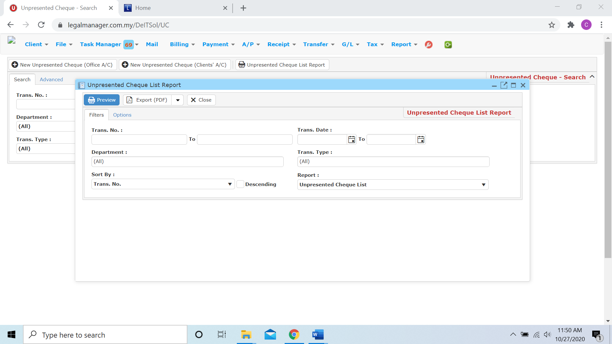

* Besides, you can preview the report as figure below shown

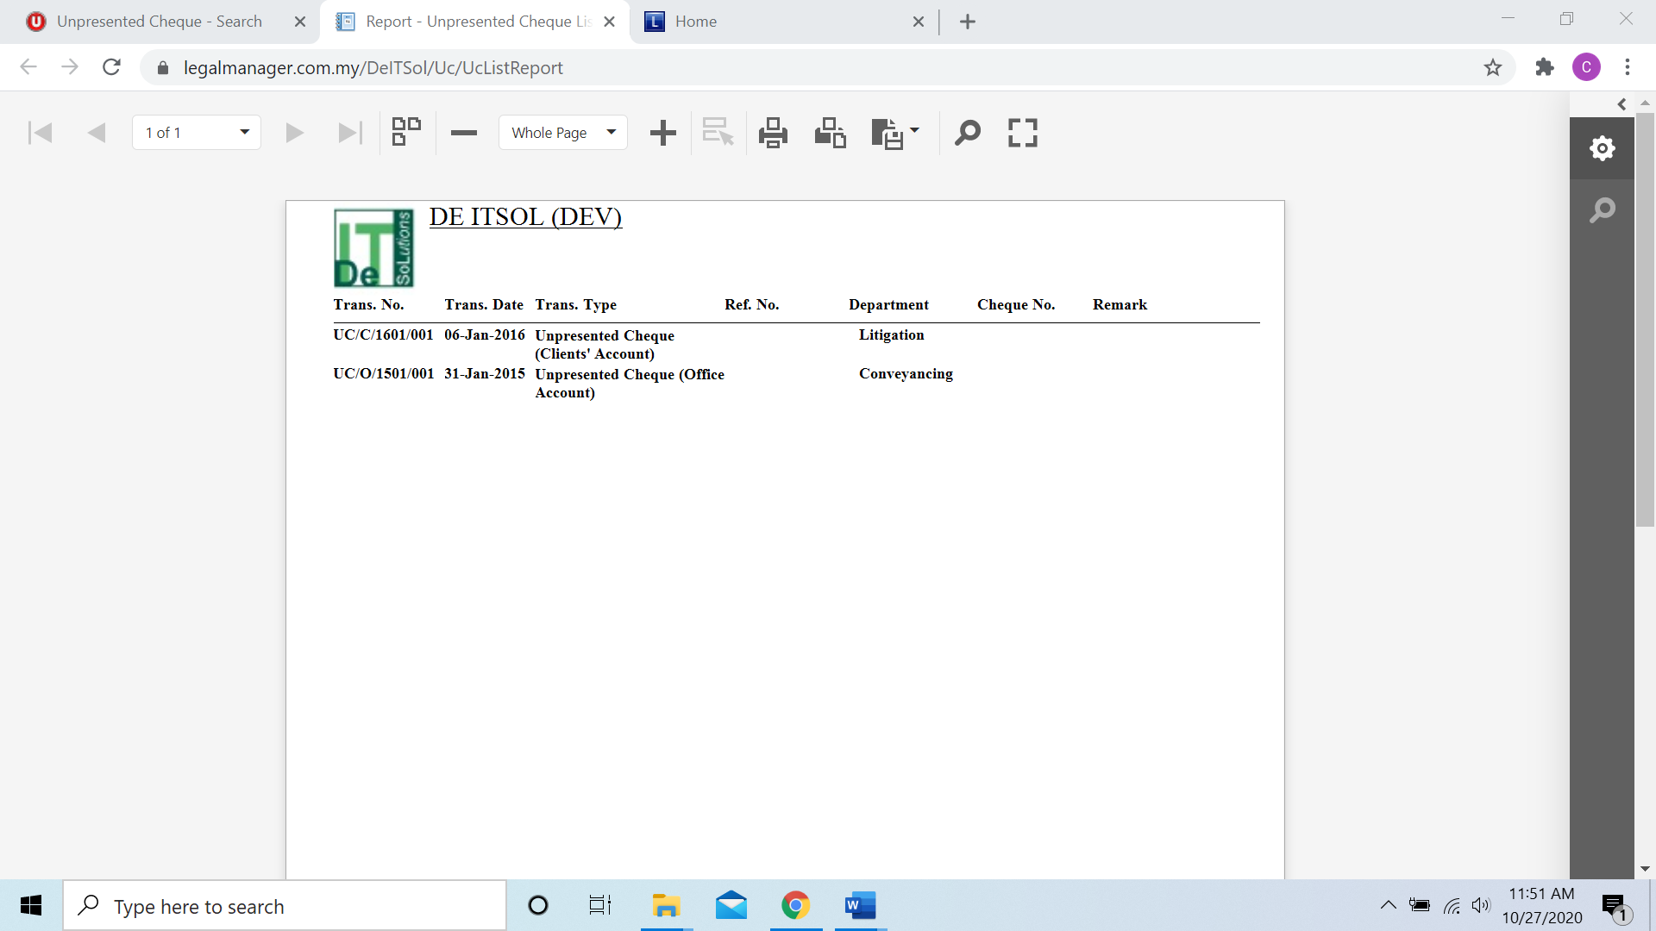

* You can also export the report into PDF or excel by clicking

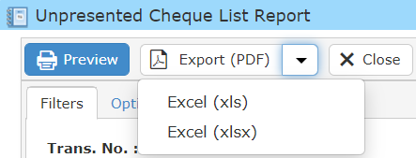

**Searched Result**

* Click ‘**Search**’ once, to show all Unpresented Cheque Record
* The Searched result will appeal at below, otherwise it will shown no record availble if the unpresented cheque you searched do not exist.
* Click ‘**Export**’ to print the desired search results in txt, excel or html format.

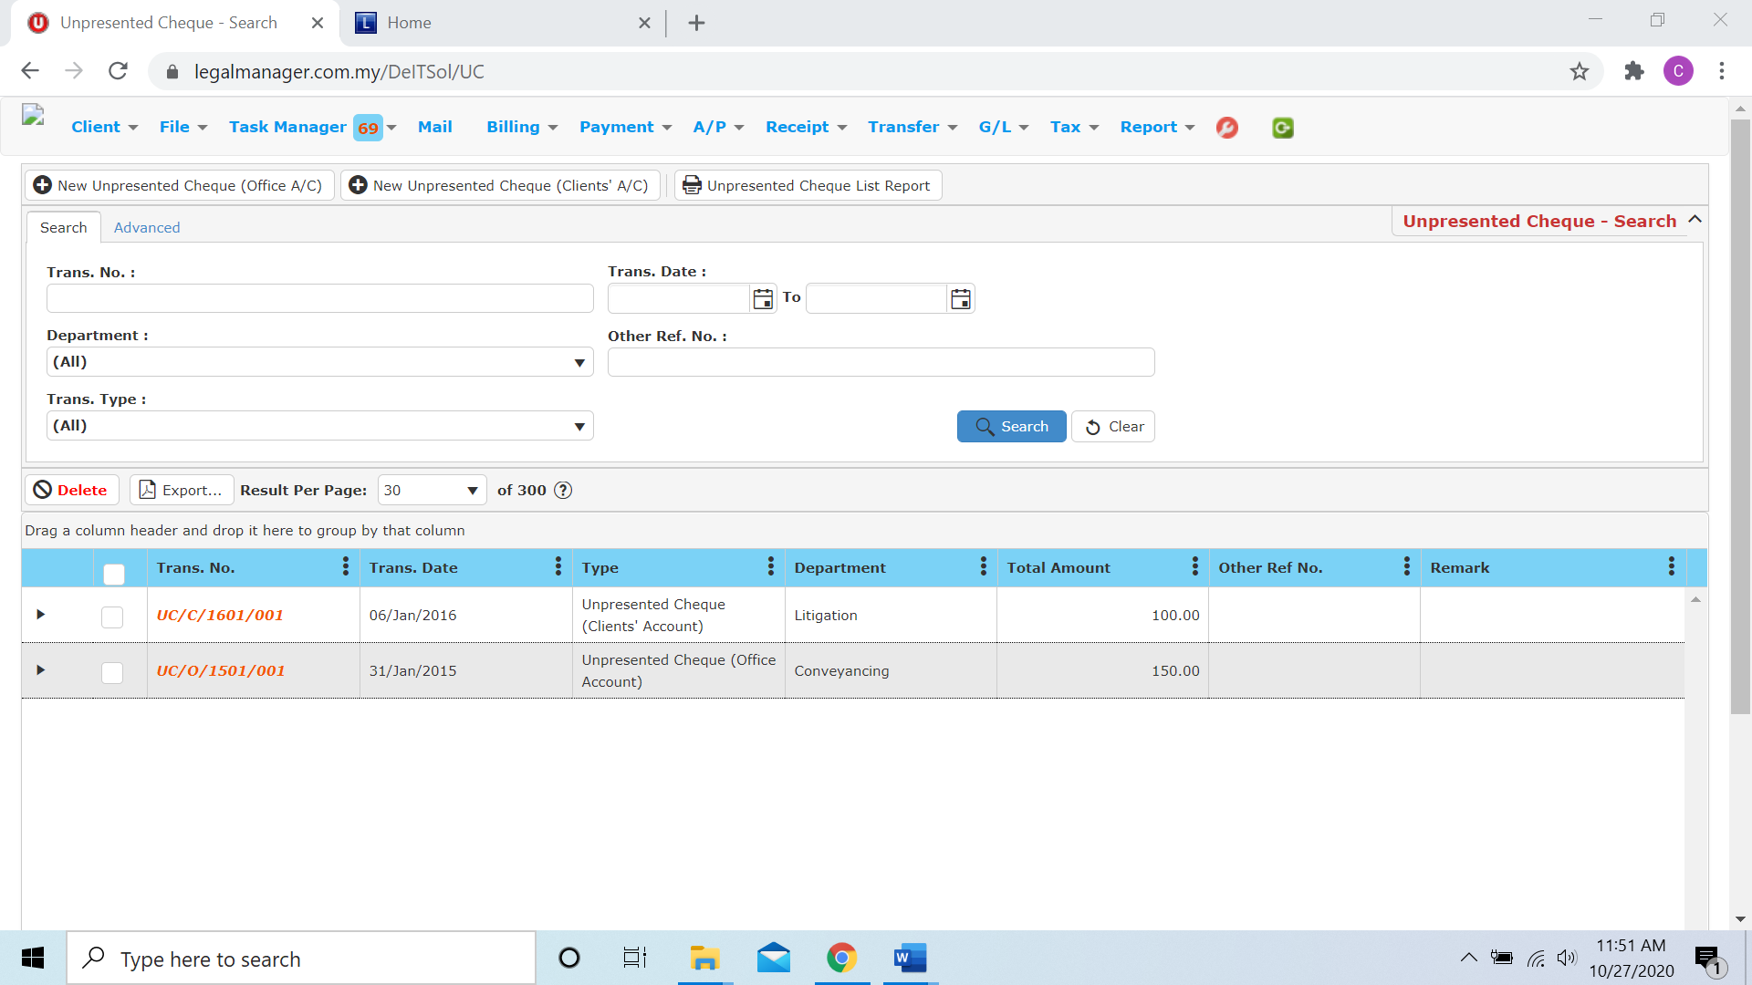

Figure: Manage Unpresented Cheque – Search All

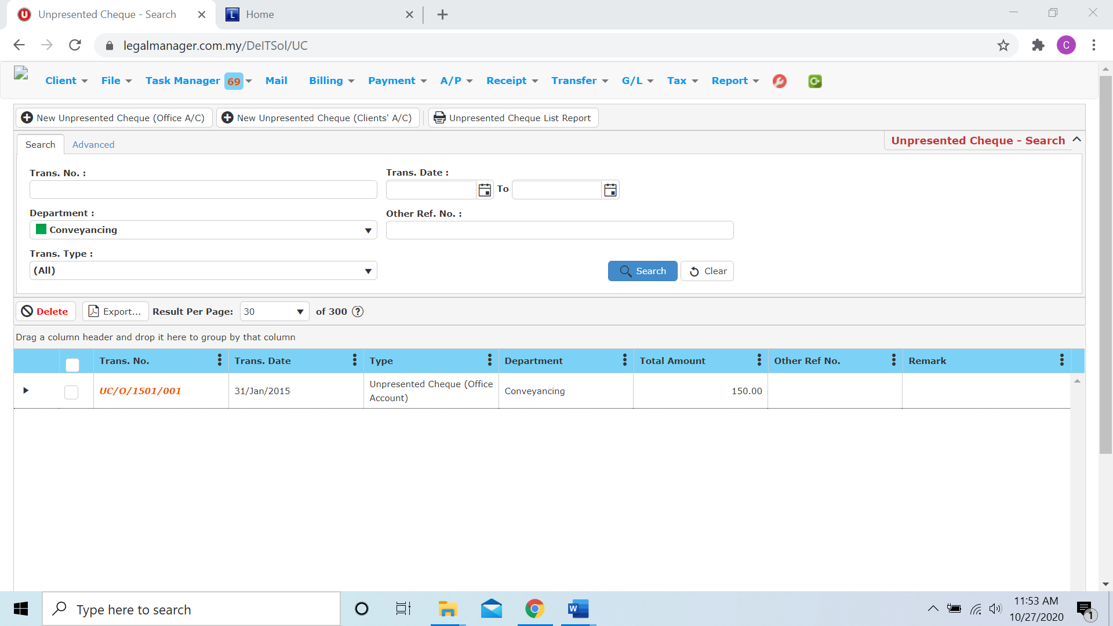

Figure: Manage Unpresented Cheque – Searched Result

* After the unpresented cheque record you searched appeal, you can choose to view, edit and preview those details by double-clicking the record.

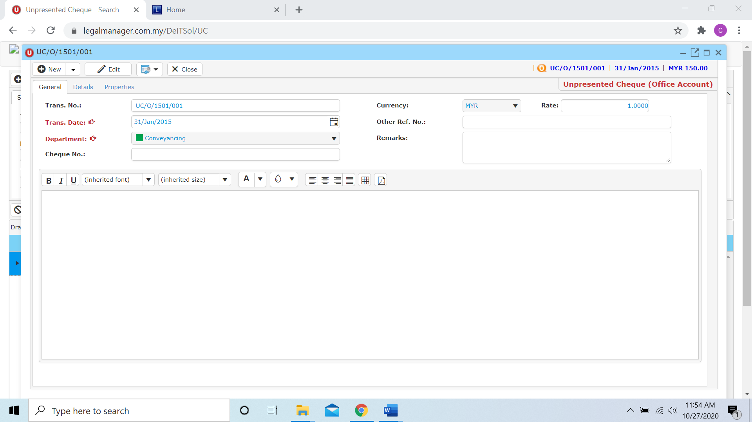

Figure: Manage Unpresented Cheque – Searched Result, Info